Installing Joomla 1.5 using Server2Go
Download Server2go from here and unzip it on your USB stick. Delete the original zip file you downloaded. Now download Joomla 1.5 from here. Unzip the Joomla folder and rename it simply Joomla. Cut and paste the newly renamed Joomla folder into the Server2go directory in the folder htdocs. Next, locate the file called server2go.exe on your USB stick. Run the program and an Internet Explorer page will open.

The first task in installing Joomla is to create a database to hold all the information for the web site we will create. To do this we will use a utility called phpMyAdmin. On the RHS is a link for phpMyAdmin, click that to create a new database.

Server2Go was originally made to run off of a read-only CD, so the default setup will not save MySQL database changes. If you want to configure the server to keep all of your settings, you need to edit pms_config.ini in the Server2Go directory so that; LocalMirror=0,OverwriteLocalMirror=0,and DeleteDatabaseFiles=0
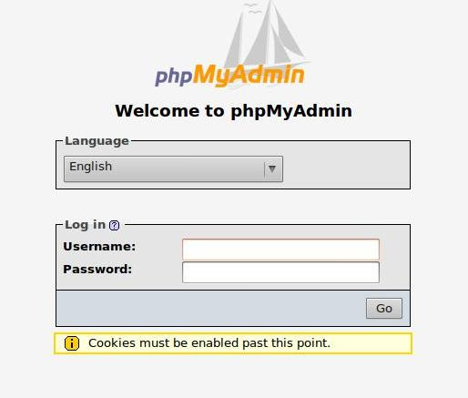

You will be presented with a login page like this one. The default credentials are username :root and password is blank. See below
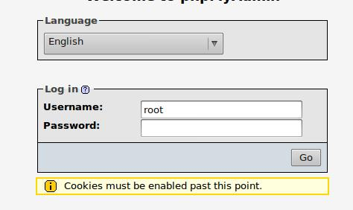

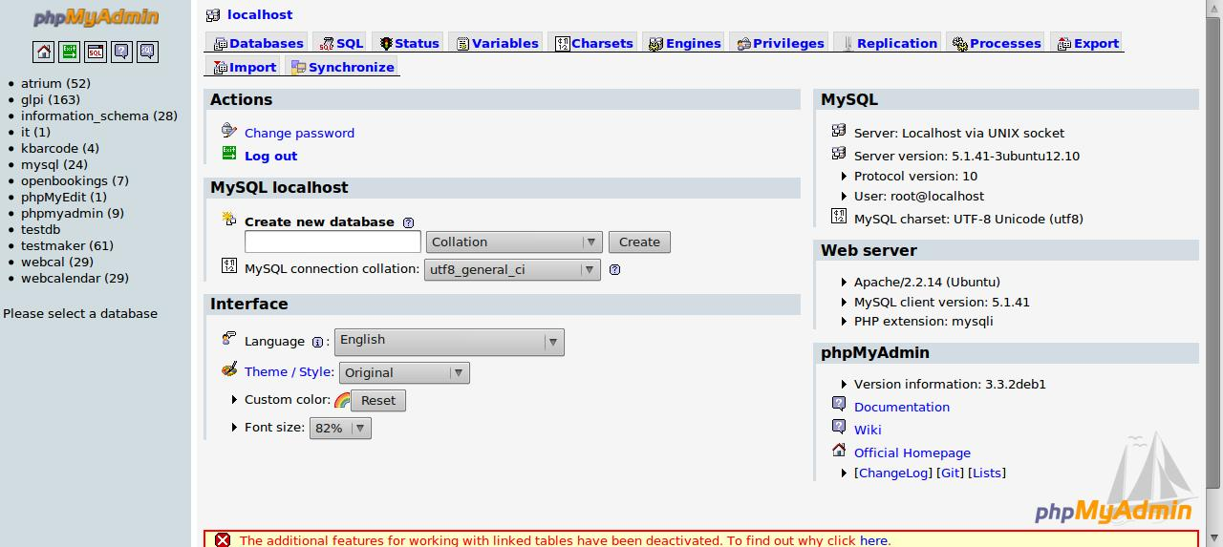
After logging in you will presented with a page like this. Note the 'create' button.
You can call your database whatever you wish but it is better to keep it simple and named according to what you are going to use it for, in this case we will call ours Joomla.

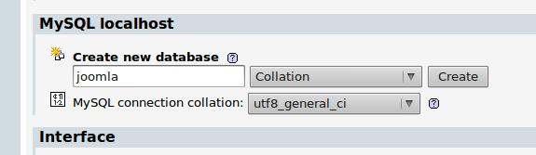
Once you have named the database then click create

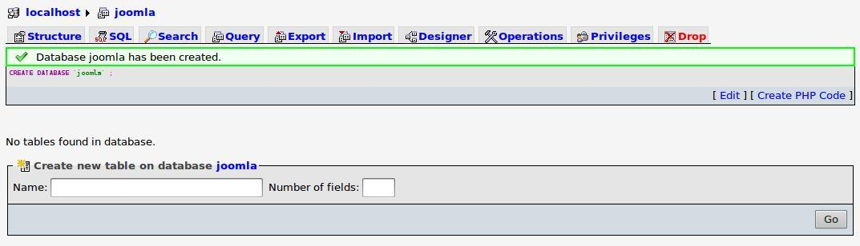
You will taken to a page like the one below and there will be a message indicating your database has been created
You can now locate the exit button at the upper left of the screen and return to the Server2Go page.

To begin the process of installing Joomla, just add Joomla to the end of the Server2Go homepage address.

First you will be asked to select a language.
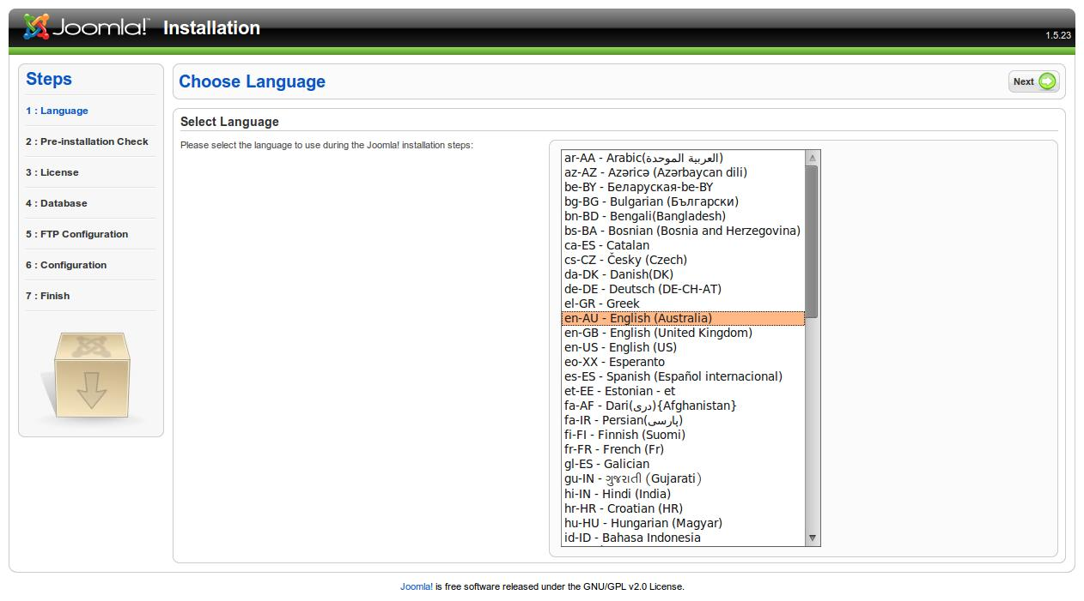

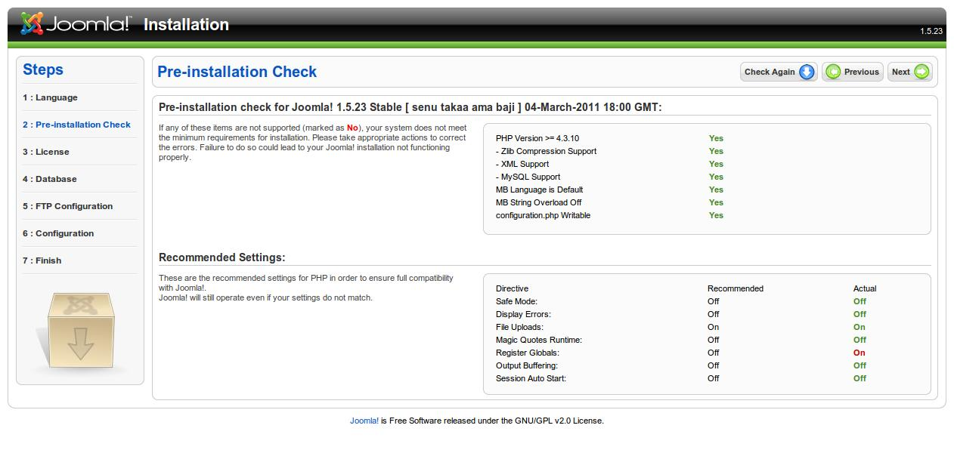
Then you will proceed to an installation check. If any of the lines in the upper right box are red the installation should not proceed. In most cases it will be because the directory into which you are trying to install Joomla is not writeable. If this is the case you will need to change permissions, see your teacher.

You will then be shown the licence for the software. This is a GNU licence indicating the software is free to use.
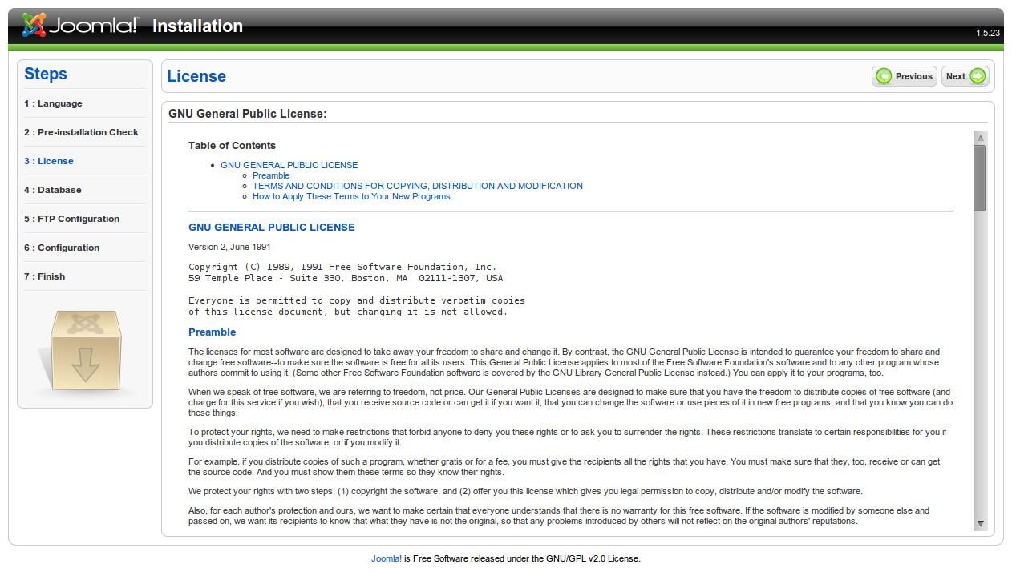

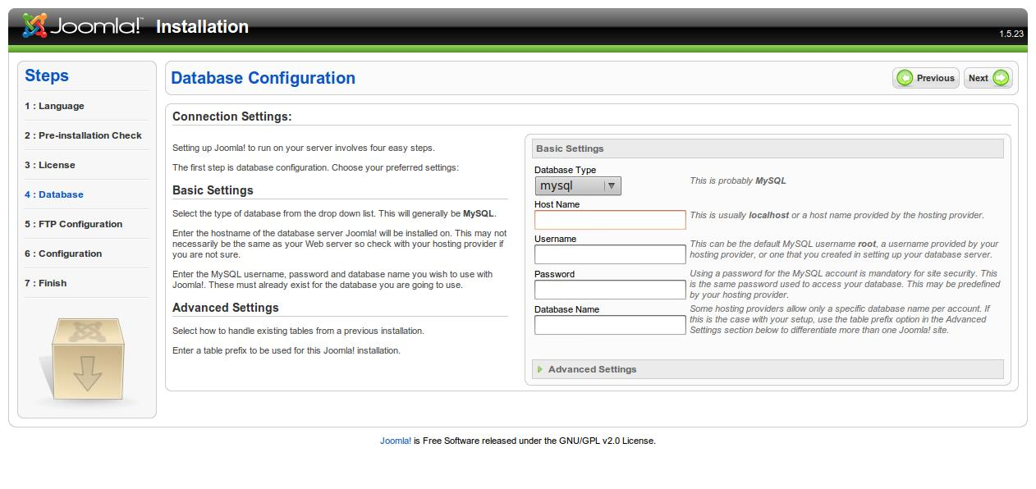
This section will take some care. Database type should be set to MySQL, Host name to localhost, username to root and password to blank (i.e. nothing) and the database name to Joomla in this case or to whatever you named your database when you created it in phpMyAdmin.
See below for an example
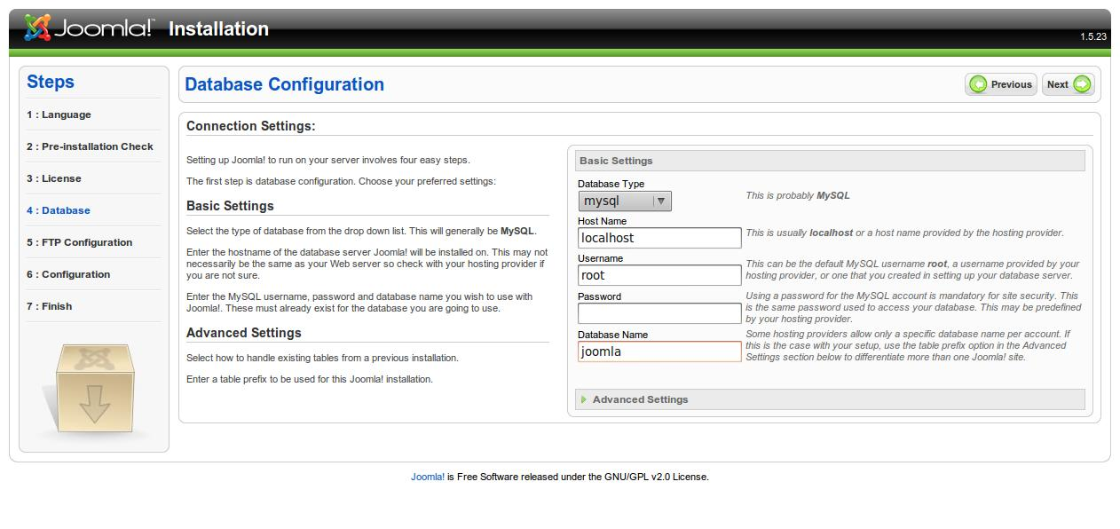
Next you will be presented with a page to configure ftp, in this installation that will not be necessary and you can skip this task.

On the next page you will be presented with a main configuration page.

You must give the site a meaningful name and a valid email address.

Write down the password you create, the default username is admin.

You should also install sample data as shown below before proceeding
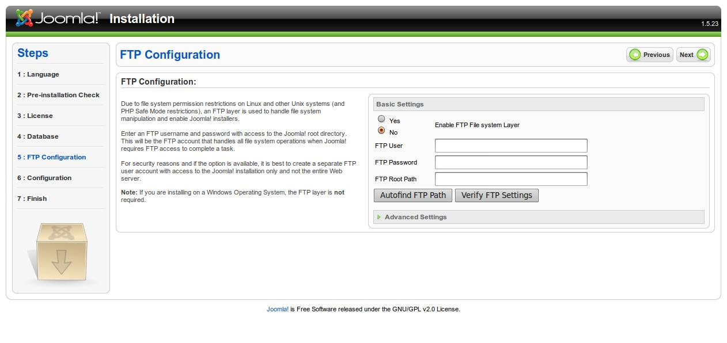
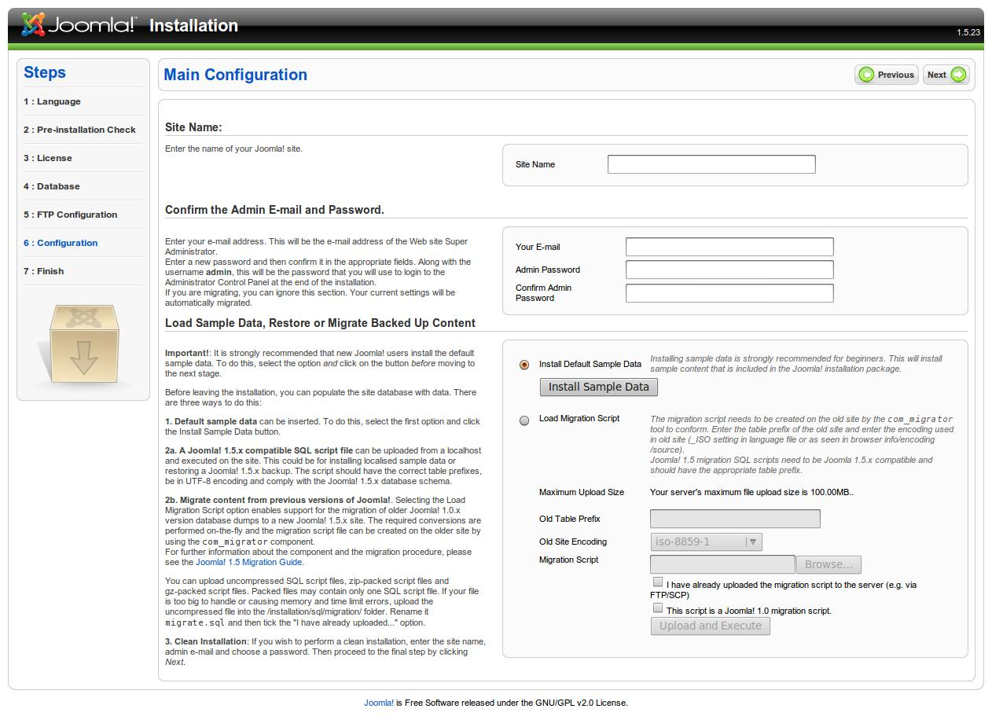
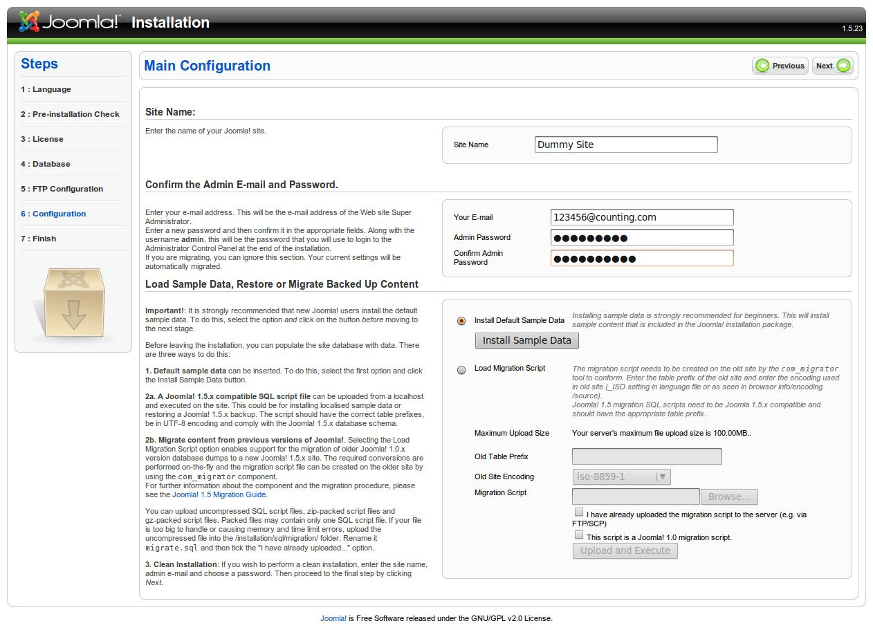
An example configuration
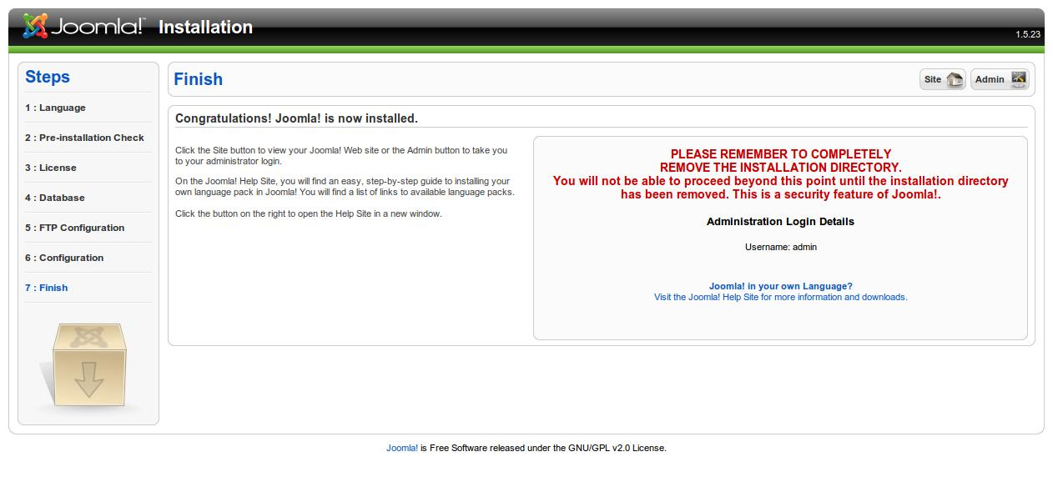
You have now finished the installation, on a real website we would totally remove the installation directory. On this one we are simply going to rename it to oldinstallation.
On your USB stick within the Server2go folder navigate to the htdocs folder and then to the Joomla folder. Rename the sub folder called Installation to oldInstallation as below;

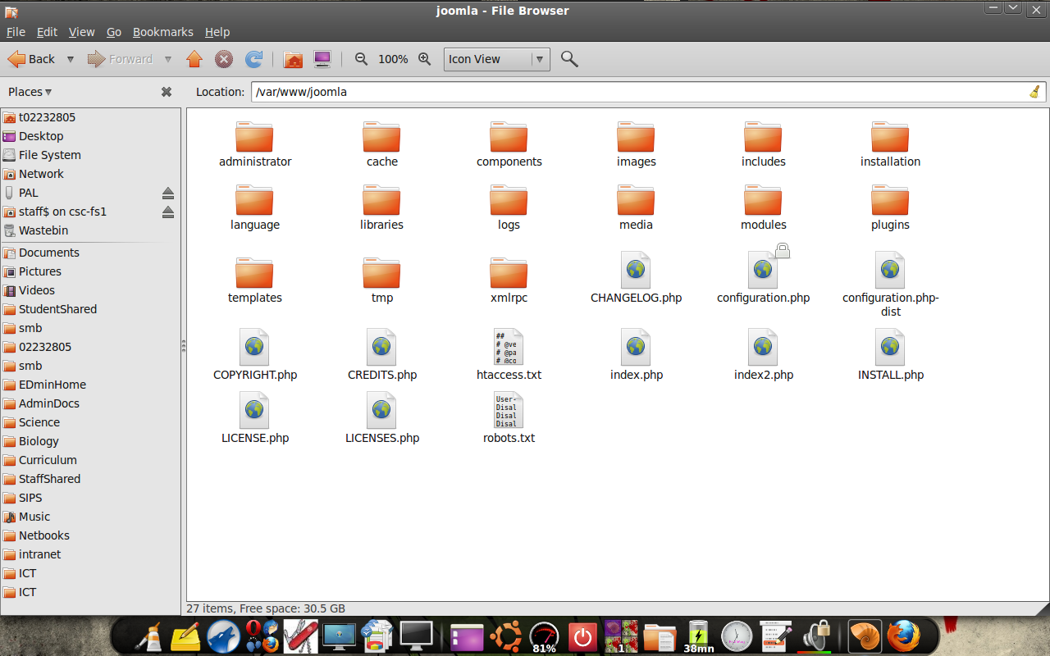

Now adding /Joomla to the Server2go homepage address will take you to this page;
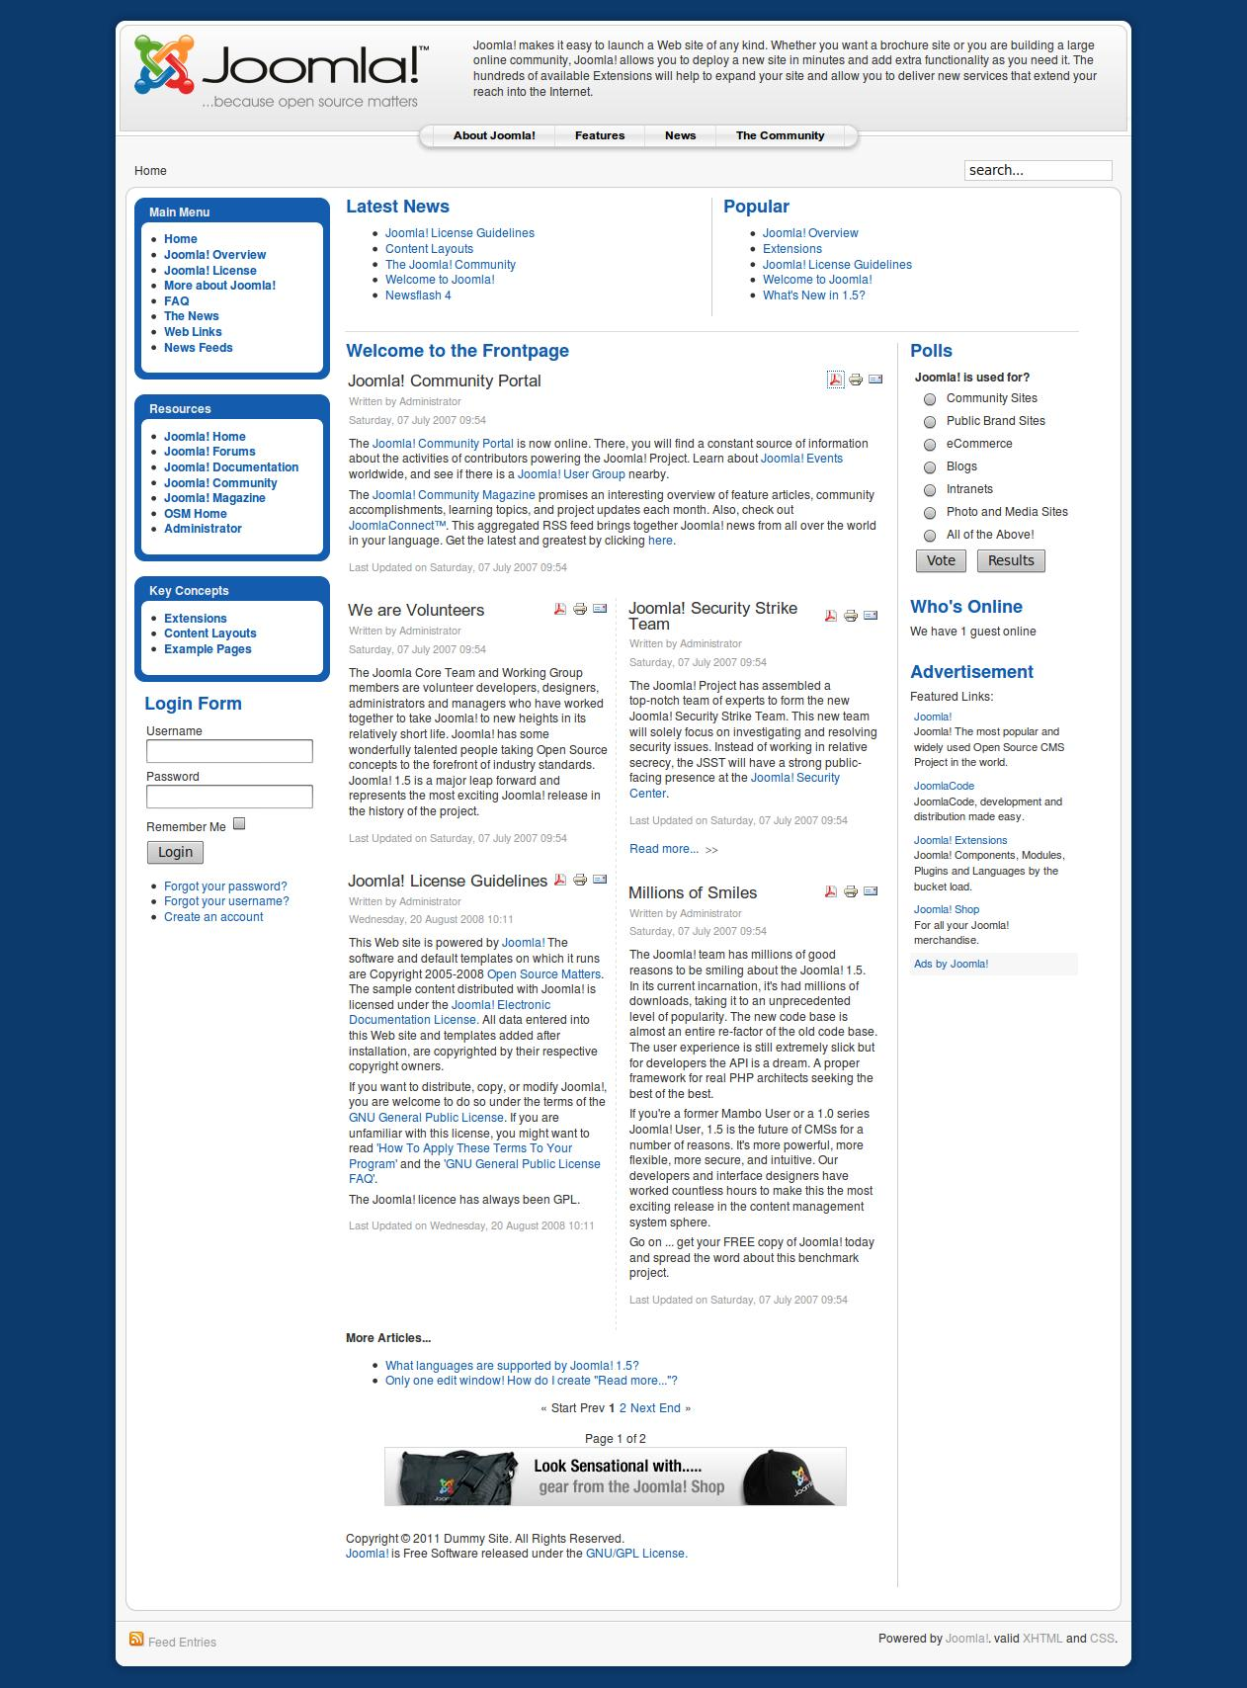
Clicking the link marked Administrator will take you to the control panel for the website as below;

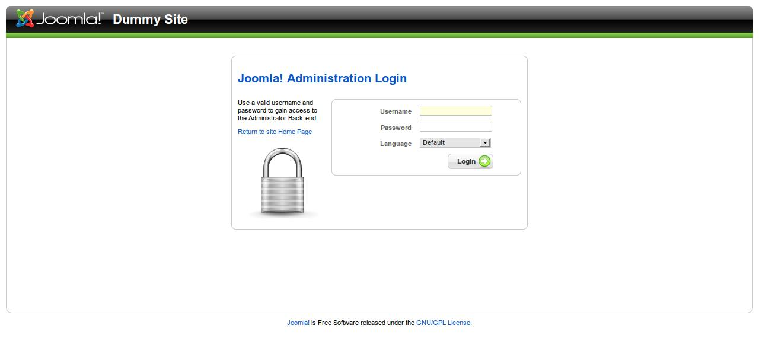
Login with the credentials you created in the setup.

Your control panel page should look like this-

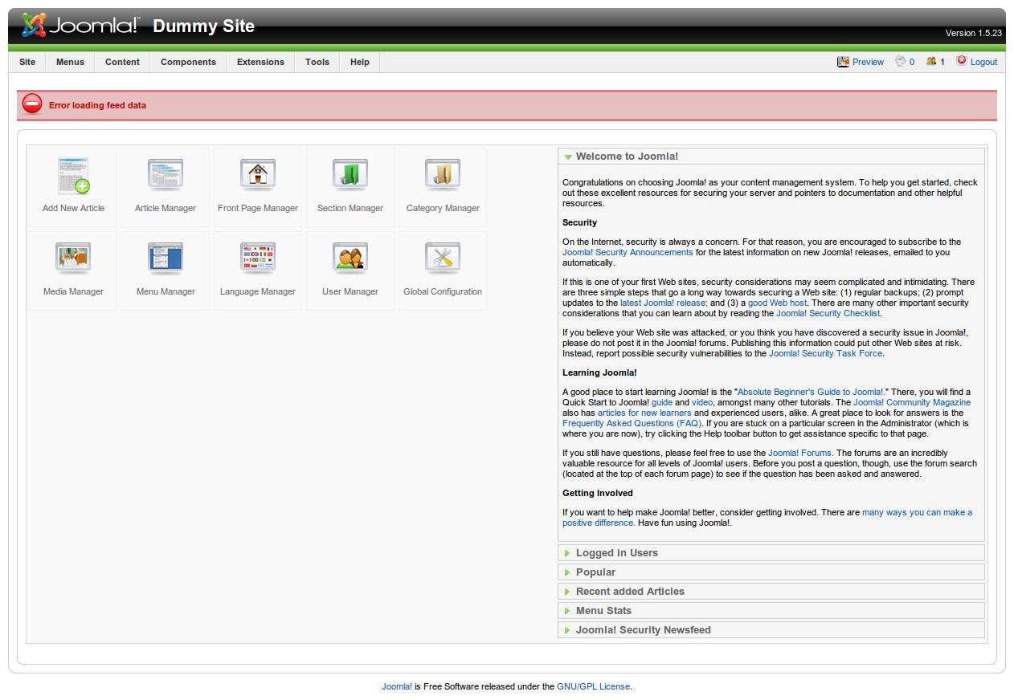
Congratulations you have finished the installation.!

