NAME: _____________________________________________
HG: _________
DUE: ____ / _____ / ______

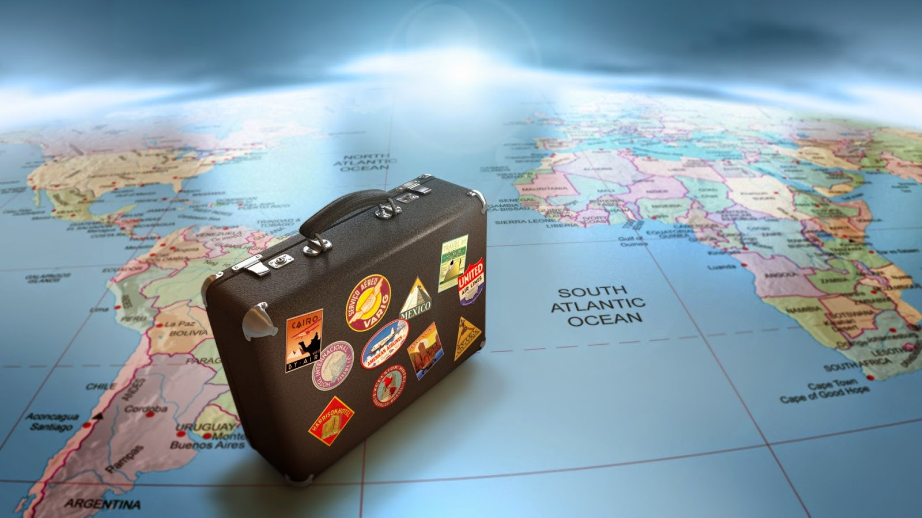

Holiday Travel Agent
Common Assessment Task
Epping Secondary College

TRAVEL AGENT TASK
7IT
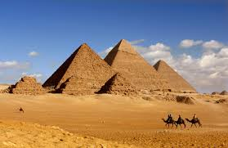 | 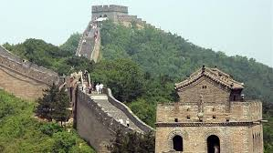 |  | 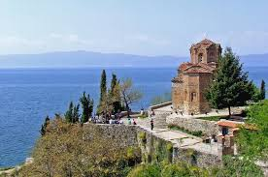 | 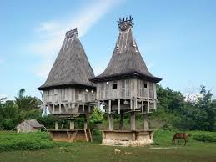 | 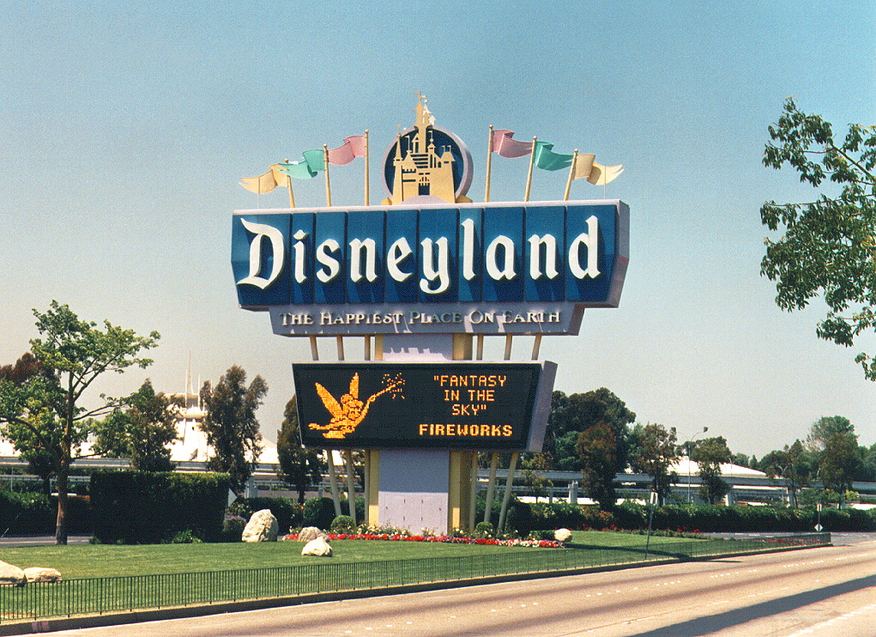
HANDOUT - STARTER
For this task you are going to be a travel agent. Your class will select the destination for you to research and prepare a holiday package for.

DATE: The dates for the holiday should be selected based on research – When are the best dates time to go?
TIME: The holiday should be for 7 nights - 4 nights in the selected city and 3 nights in another location.
TRANSPORT: The flight will leave from Melbourne Airport.
BUDGET: You should survey your class to negotiate a total budget, including spending money. Allow appropriate spending money for each day.
STEP 1 – Getting started |  |  |  |  |  | Tick & date when complete
CREATE THE ‘TRAVEL TASK - INITIALS’ FOLDER in your IT folder.
(For example – “Travel Task – LM”)
1.a. SELECT 3 COUNTRIES
Select 3 different countries to survey your class on where they would like to go.
1.b. SURVEY YOUR CLASS
Using the 3 countries you selected, survey your class as to which country they would like to go

1.c. PICK YOUR DESTINATIONS
You will need to plan to spend 4 nights in one location and 3 nights at another location
(Don’t forget to include travel time between destinations)

STEP 2 – Researching the trip |  |  |  |  |  | Tick & date when complete
2. FLIGHTS – Search the internet to research/collect flight information.

Record the following information for each flight
- Airline
- Flight Number
- Departure Date and Time
- Arrival Date and Time
- Cost

3. ACCOMMODATION – Search the internet to collect information relevant to your destination for 4 nights in one city, and 3 nights elsewhere.

Record the following information for every night of accommodation
- Name of Hotel
- Address of Hotel
- Cost of accommodation
- Hyperlinks – one for each place of accommodation
- Photos showing what each hotel looks like
- Map showing the relative location of each hotel
4. TOURIST ATTRACTIONS – Search the internet to research/collect data related to Tourist Attractions

Record the following information for each day of your trip (i.e. 8 Days)
- Name of Attraction,
- Address / Location
- Cost
- Photo of each
- Hyperlink to each tourist attraction website
5. TRANSPORT HIRE – Search the internet to research/collect data relevant to your destination.
Organise transport for all parts of the holiday

Record the following information for every day of your trip (If no transport needed – Use walking)
- Type of Transport
- Cost of Transport
STEP 3 – Budget |  |  |  |  |  | Tick & date when complete
6. CREATE YOUR BUDGET Create a holiday budget spreadsheet in Excel.

- Include all of your holiday expenses.
- Make sure to use formulas to automatically calculate the daily, total cost of your trip
- Here is an example of how you could layout your budget
HOLIDAY BUDGET
EXPENSES | PRE-PLANNING | DAY 1 | DAY 2 | DAY 3 | DAY 4 | TOTAL
AIR FARE |  |  |  |  |  | 5592
ACCOMM. |  |  |  |  |  | 800
MEALS |  |  |  |  |  | 400
SPENDING MONEY |  |  |  |  |  | 600
Activities |  |  |  |  |  | 420
TOTAL | 3500 | 2742 | 600 | 470 | 500 | 7812

STEP 4 – Itinerary |  |  |  |  |  | Tick & date when complete
7. CREATE YOUR ITINERARY
- Include a brief description of what your client will be doing each day.
- Include a relevant hyperlink if possible.
- Include a photo for each day of the trip

SELF ASSESSMENT RUBRIC
CRITERIA | 0 marks  Not shown | 1-3 mark  Beginning |  | 4-5 marks  Developing | 6 marks  Meets Expectations |  |  | 7 marks  Proficient | 8-10 marks  Exceeds Expectations
INTERNET RESEARCH |  | It was hard for you to find information sources on the internet without help.  Not much of your research suits your client.  You’ve had trouble organising and presenting your information clearly using tables and formatting in PowerPoint.  You haven’t included web addresses for most of the information collected, and haven’t used many hyperlinks. |  |  | You found information sources on the internet with some help.  Some of your research suits your client.  You’ve organised and presented some of your information clearly using tables and formatting in PowerPoint.  Some web addresses are correct and many have been hyperlinked for the information collected. |  |  |  | You found a range of information sources on the internet by yourself.  All of your research suits your client.  You’ve organised and presented all of your information very clearly using tables and formatting in PowerPoint.  All web addresses are correct & have been hyperlinked for all of the information collected.
BUDGET (Excel) |  | Few formulas have been correctly used to show daily and total budget costs.  Your information has not been clearly presented in a spreadsheet. |  |  | Some formulas have been correctly used to show daily and total budget costs.  Some of your information has been clearly presented in a spreadsheet. |  |  |  | All formulas have been correctly used to show daily and total budget costs.  All of your information has been clearly presented in a detailed spreadsheet.
ITINERARY |  | You only completed 4 or less days of your itinerary. You didn’t include much information and the presentation looks rushed. |  |  | You completed at least 6 days of your itinerary. It includes most information and looks well presented. |  |  |  | You completed all 8 days of your itinerary. It is very detailed and looks very professional.
FILE MANAGEMENT |  | Your files weren’t properly named and saved in a holiday task folder |  |  | Most of your files were correctly named and saved in a holiday task folder |  |  |  | All of your files were correctly named and saved in a holiday task folder
TIME MANAGEMENT |  | You rarely used your time well and didn’t completed many tasks on time. |  |  | You usually used your time well and completed some tasks on time. |  |  |  | You always used time well and completed tasks on time.
COMMENTS |  |  | TOTAL MARKS / 100
 |  |  | A =  80% + |  |  | B =  70-79% | C =  60-69% |  |  | D =  50-59% | E =  40-49%

