DLTV Resource Kit

For use with the VCE Computing 2016-2019 Study Design

Computing

Unit 1 Outcome 1

Learning Activities

Copyright: All Victorian Curriculum and Assessment Authority (VCAA) material is copyright. Area of Study Outcomes, Key Skills and Assessment Task descriptions reproduced by permission from the VCE Computing Study Design (2016-2019) © Victorian Curriculum and Assessment Authority (VCAA). VCE is a registered trademark of the VCAA. The VCAA makes no warranties regarding the correctness or accuracy of this DLTV resource. Teachers are advised to check the VCAA Bulletin For updates. Current VCE Study Designs and related content can be accessed directly at www.vcaa.vic.edu.au and has been reproduced with permission.

Disclaimer: This assessment task has been written by the author for Digital Learning and Teaching Victoria, for inclusion in their DLTV Resource Kit 2016-2019 to be utilised by teachers and students of VCE Computing. This does not imply that it has been endorsed by the Victorian Curriculum and Assessment Authority (VCAA). While every care has been taken by the author, he/she accepts no responsibility for the accuracy or advice contained in this task. Teachers are asked to preview and evaluate all DLTV Resource Kit resources before using them or distributing them to students.

Learning activity 1
Types and purposes of qualitative and quantitative data

Required

1. Define the term quantitative data. Give an example to support your answer.

2. Define the term qualitative data. Give an example to support your answer.

3. Complete the table below by indicating if the data acquired is quantitative or qualitative data.

Data | Quantitative or Qualitative
Tara surveyed her classmates, asking them to comment on their favourite thing about school.
Harry collected data about the maximum temperature in his town over a three month period.
Trish posted a poll on Facebook asking her friends to rate particular songs she nominated from zero to five.
Bruce ask every student in his school which AFL team they supported.
Aaron asked each neighbour in his area if they owned a computer.
Georgia timed how long it took the train to travel from Wodonga to Melbourne each day for a week.
Joyce asked commuters if they thought the time taken to travel from Wodonga to Melbourne was too long.
Jay asked commuters what could be improved about their train trip from Wodonga to Melbourne.

4. Explain an advantage of collecting qualitative data compared to quantitative data.

5. Explain a disadvantage of collecting qualitative data compared to quantitative data.

6. Explain the relationship between open and closed questions and qualitative and quantitative data.

Arnold has collected the following comments from people who have visited his restaurant. To assist him process the qualitative data he is going to group each response into one of four categories:

1. Food 2. Price 3. Staff/service 4. Wait times

7. Complete the table by indicating which of the groups listed above each comment belongs to. Identify which category is the most commonly commented on.

Comment | Group
Food not always consistent
Sometimes café seems understaffed
Can be a little too expensive
Had to wait over 40 minutes for a meal once
Food is a little overpriced
Not enough staff working on Saturdays
Wait is too long on Friday nights
Can take too long for orders to arrive
Ate there once and food was dreadful
The wait can be too long some nights
Service on some occasions is very ordinary
Too crowded some nights and had to wait
Poor service offered
Expensive for what you get
Staff have been rude on occasions

Learning activity 2
Sources of, and methods and techniques for, acquiring and referencing primary data and information

Required

1. Define the following terms:
Source of data
Method of acquiring data
Techniques of acquiring data

2. Complete the table to identify the source of, and methods and techniques used, to acquire the data listed.

Data acquired | Source | Method | Technique
Dexter asked his grandparents to complete a questionnaire by hand about their lives when they were 16 years old
Julia created a survey that is to be completed online asking every staff member if they would be happy if the business started opening on Sundays
Adrian interviewed, using Skype, a former student of the school that now works for Google in the USA
Daryl & Muriel recorded the number of cars that entered the school gate between 8am and 9am each day for a week
On the way home from school David asked Wayne a series of questions about studying Software Development
Wade arranged for 20 people to attend his office where he asked them questions about a new brand of washing powder

3. Explain what is meant by the term referencing data and information.

4. Discuss two advantages of referencing data and information.

Marlon is creating a graphic solution that represents the most popular ice-creams amongst his friends.
He is planning on include a quote from his friend Noah in the graphic solution, whose response to the question ‘which is your favourite ice-cream?’ responded with “choc tops r da bomb’.

5. List two items of information that can be used to help reference this quote on the graphic solution.

6. Explain how the footnote referencing system operates.

7. Explain how the in-text method of referencing differs from the footnote method.

8. Show how an article written by Kayla Dunn titled ‘Public Transport Rip-off’ published on page 23 the Moorabbin Advertiser on January 2016 would appear when referenced.

Learning activity 3
Factors affecting the quality of data and information

Required

1. Complete the table below matching the factor from the list below that is affecting the quality of data.

Relevance Accuracy Bias Reliability

Data | Factor affecting quality
Keith collected data from football fans about their favourite AFL team by surveying fans outside the MCG after the Collingwood versus Essendon game.
Clara created a poll to allow music fans to vote for their favourite song of 2016. There is no way of knowing if an individual votes multiple times.
Jacob interviewed a man who claimed to be a witness to a bank robbery. During the interview the witness changed his story a number of times.
Randy created a graphic solution that claimed that 80% of all Australians vote for the Labour Party. Randy only collected data from five voters.
Flyaway Airlines asked Survey’s R Us to conduct a survey of consumers about popular holiday destinations and times of year they are likely to take a holiday. One of the questions asked consumers what is their favourite colour.
Ray interviewed 20 employees of Super Land. He wrote the responses from each interview on paper, then when he finished all the interviews, he typed all the responses from each sheet into a spreadsheet.
Randy stopped 10 random people in the street to survey each of them about whether they felt that Australia should enter a free trade agreement with Zanzibar.
Mandy was conducting research in to the quality of life in Australia. She created a questionnaire on a social networking site, which was made publically available, and asked interested people to complete the survey.
For every question in an online survey each participant has to type their response into a textbox.
When viewing a website about four wheel drives a window popped up asking Daniel to complete a survey about Woman’s Day magazine.
A friend of Cecil’s emailed her a dataset about water storage levels of dams in Victoria, but there is no indication of the source of the dataset.
Donald asked volunteers from around Melbourne to submit traffic updates each morning so he could publish on his twitter feed a graphic solution highlighting roads to avoid. Many volunteers instead submitted news on how to make money quick on the internet.

2. Write one sentence describing the meaning of each of the following factors of quality data.

Factor | Description
Relevance
Accuracy
Bias
Reliability

3. Outline a technique that can be used to protect the quality of data for each of the factors listed.

Factor | Technique
Relevance
Accuracy
Bias
Reliability

4. Explain why collecting data using the method of an interview and the technique of a face to face may provide more reliable data than asking participants to complete an online survey.

Learning activity 4
Techniques for authorising the collection and use of data and information

Brandi Brown is the president of Mad Dog’s dog obedience club that meets each Sunday morning in a local park in a suburb of Melbourne.

Brandi is hoping to collect data from all the members of her club, including: the suburbs where members live, if members are happy with the current membership fee, the quality of the training offered and any general comments or suggestions each member would like to make. She is hoping that each member identifies themselves on the form by entering their Member ID, but she is going to de-personalise the data once collected. Once collected she will use the information to target future advertising campaigns, make changes to the types of classes offered, review the current membership fee structure and consider adding new services. Brandi will store the data on her personal laptop. The laptop has password security, system protection software installed and the file containing the data will be encrypted on the hard drive.

Before Brandi collects the data she would like to produce a consent form which can be used to inform the members of the data that is to be collected and how the data will be used once collected.

She would like the consent form to include:

- the name of the organisation
- the date the consent form was created
- the title of the project
- the person responsible for the project (Brandi)
- the purpose of the survey
- a list of data to be collected
- how the data is to be used, including de-personalising the data
- how the data is secured and stored
- an area for the member to sign and advise where to return the form.

Required

1. Referring to one legal obligation, explain why it is necessary to gain the consent from individuals before collecting data and information.

2. Create a consent form for Brandi that meets all of the above requirements.

Note: The consent form can be created using word processing software

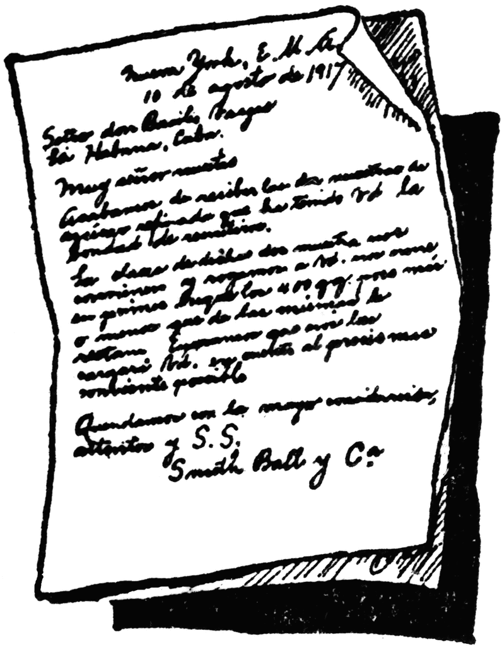

Many organisations use a terms and conditions check box when they wish to collect data from individuals, particularly online, rather than an explicit consent form.

- I agree to the terms and conditions
3. Discuss one advantage and one disadvantage for individuals in expressing their consent using this method.

4. Explain if it is legal to collect data from persons under the age of 18 without receiving their parents permission.

5. Distinguish between a consent form and a participation information statement.

Learning activity 5
Techniques for protecting the privacy of providers of data and information

Required

1. Explain an advantage of making participants aware that data collected will be treated anonymously.

Below is a sample of data that has been collected as part of an investigation into student achievement at a school in Victoria.

Student ID | First Name | Surname | Year Level | Tutor Group | Postcode | English | Maths | Science
2341 | Christian | Graves | 7 | B | 3978 | A | A | B
2342 | Grace | Ruiz | 9 | E | 3975 | B | A | B
2343 | Martin | Clark | 10 | D | 3971 | A | A | A
2344 | Thelma | Cook | 8 | B | 3979 | C | B | A
2345 | Audrey | Parsons | 11 | A | 3981 | A | B | C

After the data has been collected the data was de-personalised and the de-personalised data is shown below:
Student ID | Year Level | Tutor Group | Postcode | English | Maths | Science
2341 | 7 | B | 3978 | A | A | B
2342 | 9 | E | 3975 | B | A | B
2343 | 10 | D | 3971 | A | A | A
2344 | 8 | B | 3979 | C | B | A
2345 | 11 | A | 3981 | A | B | C

2. Describe the technique used to de-personalise the data.

The Student ID number is issued by the school to uniquely identify each student.

3. Outline a problem with continuing to use the Student ID field once the data has been de-personalised.

4. Even if the Student ID column is removed from the data describe why, based upon the remaining data, that the privacy of each of the students is not guaranteed.

The purpose of the data collection is to calculate the total number of each grade (e.g. A, B, C), received in each subject, at each year level at the school. E.g. in year 7 twelve students received an A grade in Maths.

5. Re-draw the table showing only the required headings to produce the information required by the school.

6. Explain why your solution in question 5 will increase the privacy of the students.

Learning activity 6
Physical and software controls used to protect the security of stored data

Required

1. Explain how physical security controls differ to software security controls. Give an example of each to support your answer.

____________________________________________________________________________

2. Complete the table below to identify if each measure is a physical control or a software control. Describe how each control operates and identify the threat to data it addresses.

Control | Physical or software | Description
Backing up
CCTV
Username and password
Locks on doors
Systems protection software
Encryption
Security cable and lock
Firewall

3. Explain how systems protection software differs from anti-virus software.

4. Complete the table below to indicate which security measure would be appropriate to protect the data and information.

Security threat | Security control
Ormond University provides computer labs for students to enable them to study and access resources. They need a method to stop people other than students entering the labs and accessing the data and information.
Mercedes needs to ensure that the medical details she has collected as part of a research project is protected when sent across the internet to a fellow researcher on the project.
Martin is a marine biologist. He spends time working in on an island in the Great Barrier Reef where he collects data about turtles. His office is located in a small shack on the island but he is worried that wild weather or a hurricane may destroy the shack and he will lose all the data collected.
Kara has been noticing an increase in the number of spam emails she has been receiving and also an increase in the number of unwanted pop-up advertisements when surfing the internet.
Craig is worried that one of the new members of staff may, by mistake, remove the portable hard disk drive from the server room that contains all the backed up files of the organisation.
Christian has noticed an abnormal increase in data traffic entering the school’s network from the internet.
Calvin is giving a presentation at a college in the city about his research into the social networking habits of university students. He has connected his personal laptop to the projector in the lecture theatre, then he has to leave to attend a session in another room first, but is worried his laptop may be stolen.
Oscar has set up a weather station at his school to collect data, just outside one of the buildings in an area protected by fencing. He is still worried that outside school hours someone might come along and try and vandalise the equipment.

5. Outline one other physical control and one other software control not already mentioned in this activity.

Learning activity 7
Australian privacy principles relating to the acquisition, management and communication of data and information

Required

1. Outline the purpose of the Privacy Act 1988. Indicate if the Act is a Victorian Act or a Federal Act.

2. List the number of Australian Privacy Principles are contained in the Privacy Act 1988.

3. Describe the subject of the following Australian Privacy Principles.

Australian Privacy Principle | Description
Principle 2
Principle 6

4. Outline a technique that can be used to ensure that data collected meets the requirements of Principle 2.

5. Explain a link between Principle 6 and the use of consent forms when collecting data from participants.

6. Complete the table below to indicate the Australian Privacy Principle breached in each scenario.

Scenario | Principle breached
Donna manages the school canteen. She has been collecting data from students regarding their suggestions for new products they would like added to the menu. One of the canteen’s suppliers, Crazy Donuts, has asked Donna if they can buy the data from her to be used by the company.
Jess is collecting data about the method of transport Year 12 students use to travel to and from school each day. All participants are required to submit their name when submitting data.
When submitting data to an online poll regarding the frequency of visits made to a local shopping centre, participants are required to enter their email address as part of the data collection process.
When collecting data regarding the frequency of visits that shoppers make to an shopping centre, the shopping centre management then sells the email addresses of all participants to Car Wash 4 U, who are located at the centre, without the knowledge the participants.

7. Identify one other Australian Privacy Principle related to the collection of data and one related to the management of data.

Learning activity 8
Ethical dilemmas arising from data acquisition strategies

Required

1. Describe the term acting ethically.

2. Explain how an ethical obligation differs from a legal obligation.

3. Define the term ethical dilemma.

Harry will be collecting data related to the food types that other students eat for breakfast and lunch. Once the data is collected Harry is planning to create an infographic displaying the food choices made by students at the school. All participants signed a consent form which outlined what data is to be collected, how the data will be used and that all data will be de-personalised after collection.

When manipulating the data, Harry uncovered that one student was not eating at all. He feels that he should tell someone at the school about the student so the issue can be investigated further and assistance found.

4. Outline the two sides of the dilemma that Harry faces.

Sonia has collected data from her fellow workmates. She is planning to use the data collected to plan a series of social events over the upcoming year. A friend of Sonia’s, who sells life insurance, has asked Sonia if she will sell her a list of all the names and phone numbers that she has collected. Sonia could use the money to help fund the social events she has planned.

5. Explain how Sonia may breach a legal obligation and an ethical obligation if she sells the data.

6. Explain both sides of the ethical dilemma Sonia now faces.

7. Besides not selling the data, describe another procedure that Sonia could follow to avoid breaching both legal and ethical obligations.

8. Explain the purpose of an ethical framework.

Learning activity 9
Types of graphic solutions for educating, persuading and informing audiences

Required

1. Discuss two advantages of presenting data in a graphical format.

2. Complete the table below by defining each type of graphic solution.

Graphic solution | Definition
Chart
Flowchart
Diagram
Image
Hierarchy
Animation
Map
Timeline
Infographic

3. Complete the table to indicate an appropriate type of graphic solution to represent the data.

Graphic solution | Type
Aaron needs to show how he has structured his web pages, displaying the results of his investigation, on his website.
Liam wants to show all the planets in our solar system, including displaying each planet’s distance from earth.
Lorna requires a graphic solution that displays all the significant events that have occurred in her hometown over the last 100 years.
Jacinta wants to present an image of a hamburger on a poster, with statistics added around the image informing about the nutritional contents a hamburger.
Sammi wants to represent the number of ice-creams sold compared to the number of chocolate bars sold.
Michelle has a series of images she would like to display to users. She is hoping to display one image at a time with an audio voiceover.
Anushka wants to show the steps required to log on and then post an image on a social networking site.
Damian needs a solution that will allow him to show how the amount of that has occurred in different parts of Victoria.
Lucinda wants to make a graphic representation of her house, showing all the different rooms and their sizes.
Isabel needs to compare the height of students in her class against the weight of each student.

Hugh Arms owns and operates a fitness centre. Recently he conducted a survey of his members and amongst the data he received the following complaints regarding the centre:
Some weights are a bit old | Run promotions on Saturdays
Equipment needs some maintenance | Too many people during the week
Whole fitness area needs an upgrade | Rowing machine must be 20 years old
Change rooms need cleaning more frequently | Could do with a greater range of weights
On one visit the change rooms were disgusting | Need more modern equipment
Can be too crowded some weeknights | Could update some of the machines
Hire staff that know who they are doing | Can get too busy at times
Clean change rooms more frequently

4. Create a graphic solution that will appropriately represent the data visually. Indicate in which area Hugh should first focus to improve the centre.
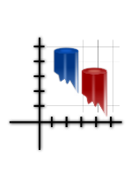

Learning activity 10
Design tools for representing the functionality and appearance of graphic solutions

Required

1. Describe two advantages of completing a design of a graphic solution before developing the solution.

2. Explain the difference between design tools for functionality and design tools for appearance.

Melinda has acquired data from a local real estate agent. She has collected the selling price for all houses sold in her suburb for 2015. She has also collected the average selling price of all houses in Australia for 2015.

Melinda is going to calculate the average selling price of all the houses in her suburb, then using the charting feature in spreadsheet software, she is going to create a graphic solution comparing the average selling price in her suburb compared against the Australian average.

Melinda has created an input-process-output (IPO) chart below to represent the functionality of her graphic solution.
3. Complete the IPO chart below to identify the missing process from Melinda’s investigation.

Input | Process | Output
Selling prices in her suburb |  | Graphic solution
Australian average | Charting function

Nelson is conducting an investigation into the TV viewing habits of his students in class. He has collected data regarding the number of students who prefer to watch free to air TV, the number of students who prefer to watch pay TV and the number of students who prefer to watch shows that have been streamed from the internet.

Method | Number of students
Free to air | 6
Pay TV | 6
Internet streaming | 12

After the data is completed Nelson is going to calculate the percentage of students who watch each method, then manipulate the percentages using a charting function in the software he is using to represent the data as a graphic solution.

4. Complete the input-processing-output (IPO) chart below to represent how his solution will function.

Input | Process | Output

5. Complete an annotated diagram/mockup to show how the graphic solution will appear after Nelson has manipulated the data. Include in the diagram a title, legend and source of the data.

Annotate the diagram to show the text styles and sizes and colours to be used in the solution.

UNIT 1 OUTCOME 1
DATA AND GRAPHIC SOLUTIONS

Required

1. Explain how a format differs from a convention.

Formats and conventions suitable for graphic solutions include titles, shapes, source of data and legend

2. List three other formats and conventions suitable for graphic solutions.

Below is a graphic solution that is comparing the population, life expectancy and average income of five different countries.

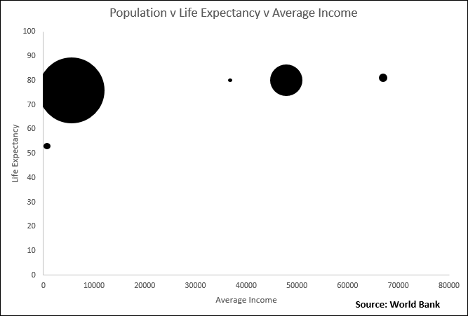

3. Identify three formats or conventions that have been applied to the graphic solution above.

4. Identify one format or convention missing from the solution. Explain how this missing format or convention makes the graphic solution practically useless.

____________________________________________________________________________

The graphic solution below represents the number of ice-creams sold by a business over the weekend.

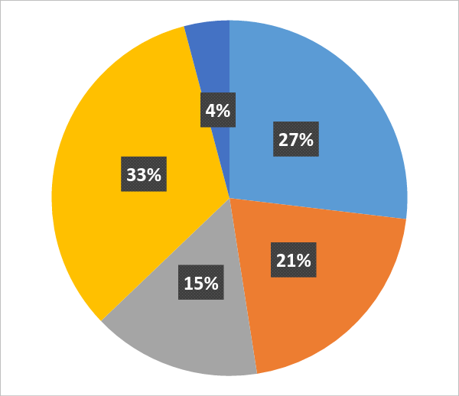

5. Identify two conventions that have not been included in the solution. Explain how the omission of the formats and conventions have affected the effectiveness of the solution.

Learning activity 12
Software functions and techniques to efficiently and effectively manipulate data into graphic solutions, and for validating data

Required

1. Define the term validation.

When Bethany was creating an online survey she created a drop down list for students to enter their year level.

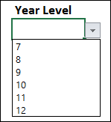

2. Explain how a drop down list will assist to validate the data acquired.

3. Discuss two other software controls that can be used to validate data.

4. Define the term manipulation.

5. Besides spreadsheet software, outline two other software types that can be used to manipulate data into a graphical solution.

Merinda started to create an infographic using image manipulation software:

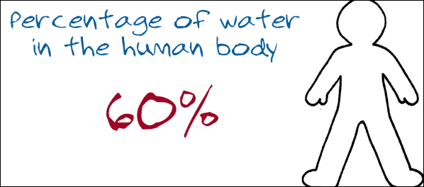

One technique she used to create the graphic solution was using layers within the image manipulation software.

6. Explain why using layers is an appropriate technique to create graphic solutions.

Learning activity 13
Testing graphic solutions

Required

1. Explain how testing differs from both validation and manipulation.

2. Complete the table below to define each of the following types of testing that can be used with graphic solutions.

Testing type | Definition
Completeness
Reliability
Presentation
Functionality
Relevance
Communication of message

Candice has collected the following data related to smoking rates in five countries:
Country | USA | UK | Canada | Netherlands | Australia
Rate | 20% | 22% | 16% | 34% | 15%

She then used presentation software to manipulate the data into a graphic solution. The graphic solution is shown below:

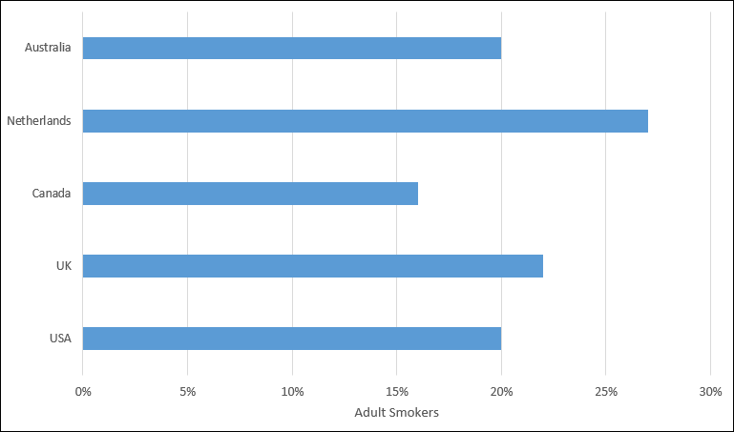

3. Complete the test table below to check if all the elements of the graphic solution are as expected.

Test | Expected result | Actual result
Graphic solution is accurate | Smoking rate for each country on the graphic solution is the same as in the data
Graphic solution is complete | Heading appears at top of the graph and axis labels are used on both the X and Y axis
Graphic solution clearly communicates the message | The country with the highest smoking rate is clearly identified
The presentation of the graphic solution is clear | The colours and contrast used make it easy for the information to be read
Information provided is relevant | Only information relating to smoking rates appear on the graphic solution
Graphic solution is reliable | The source of the data is clearly identified

