End of Year Exam Cover Sheet 2017

Student Name:______________________Homeroom:_______

Teacher’s Name___________________________

VCE COMPUTING UNIT 2

Wednesday 8th November 2017

Reading Time 1:15pm to 1:20pm (5 mins)
Writing Time 1:20pm to 2:50pm (90 mins)

QUESTION AND ANSWER BOOK

Structure of book
Sections | Number of questions to be answered | Number of  marks
Section A | 20 | 20
Section B | 10 | 80

Materials required
• Students are permitted to bring into the examination room: pens, pencils, highlighters, erasers, sharpeners, rulers, and one scientific calculator.
• Students are NOT permitted to bring into the examination room: blank sheets of paper and/or white out liquid/tape.

Materials supplied
• Question and answer book.
• Additional space is available at the end of the book if you need extra paper to complete an answer.

Instructions
• Write your name, Homeroom and teacher’s name in the space provided above on this page.
• You should make use of stimulus material where it is included. However, it is not intended that this material will provide you with all the information to fully answer the question.
• All written responses must be in English.

Students are NOT permitted to bring mobile phones and/or any other unauthorised electronic devices into the examination room.

SECTION A – MULTIPLE CHOICE
Instructions for Section A
Circle/Highlight the response that is correct or that best answers the question.

A correct answer scores 1, an incorrect answer scores 0.

Marks will not be deducted for incorrect answers.

No marks will be given if more than one answer is completed for any question

Question 1
A compiler:
A. converts pseudocode into source code
B. lets programmers edit source code
C. ports software from one platform to another
D. converts source code into executable code

Question 2
A platform is:
A. the hardware in a computer
B. a combination of CPU and operating system
C. another word for a programming language
D. the list of commands made available by a programming language

Question 3
The difference between data and information is that:
A. data is processed to create information.
B. information is processed to create data.
C. data is more complex than information.
D. information is more reliable than data.

Question 4
RAM:
A. stores programs and data between runtimes.
B. is software permanently burnt into silicon chips.
C. is stored on disk.
D. loses its data when the power is turned off.
Question 5
Solid state disks (SSD) are so-called because:
A. they keep their memory when power is turned off
B. they are built in a way that prevents their read/write heads from crashing
C. they have no moving parts
D. they never fail

Question 6
A variable:
A. stores multiple values in RAM
B. stores a record on disk
C. has a value that is set once and cannot be changed again
D. stores a value in RAM

Question 7
A floating point value:
A. can store decimal places
B. can change its value without intervention by the programmer
C. can store text data
D. can store any sort of data

Question 8
Boolean data type is used to store:
A. a single text character
B. a pointer to a memory location
C. a series of numbers
D. true/false values

Question 9
When storing graphic, video or audio data, it is common to reduce its storage requirement and transmission time using:
A. validation
B. compression
C. iteration
D. encryption

Question 10
Primary data:
A. is collected first-hand by the researcher
B. is processed into secondary data
C. is used by younger students
D. is often biased

Question 11
You would expect reliable & unbiased information about Australian politics from:
A. the ALP or Liberal Party websites
B. TV political commentators
C. newspaper editorials
D. a VCE politics textbook

Question 12
If data has integrity, it:
A. is in one piece
B. is accurate, timely, authentic and relevant
C. has good character
D. has been generated from good secondary data

Question 13
Sally is creating a database for a shop that sells chocolate and delivers online. She makes one field of the online order form compulsory, so people cannot complete a purchase unless they enter a value for that field. The compulsory field might be:
A. their phone number
B. an email address
C. their date of birth
D. their residential address

Question 14
Timely data:
A. is produced quickly
B. relates to a time of day
C. is current and available when needed
D. is stored in a field with a time/date data type
Question 15
A researcher creates a database to store survey data. One question asks how many children the respondents have. What data type should the answer be?
A. Boolean
B. numChildren
C. Floating point
D. Integer

Question 16
Nick collects data about the amount of rainfall in his backyard every day. To store a year’s worth of data during processing, he should use:
A. a record
B. an array
C. a text file
D. a field

Question 17
Nick wants to show clearly how rainfall changes across the course of an entire year. He should create a:
A. line chart
B. pie chart
C. table
D. map

Question 18
A database query is used to:
A. search for databases online
B. find certain records in a database
C. check that a database is working properly
D. format database information for display

Question 19
Data redundancy refers to:
A. out-of-date data that needs to be cleansed
B. irrelevant data
C. data backups
D. unnecessary copies of the same data
Question 20
A record in a database consists of:
A. a multiple fields of various data types
B. one piece of data
C. names, addresses and dates of birth
D. ID values or account numbers
SECTION B – SHORT ANSWERS
Question 1
John Hillier has a database of international companies with which his company does business. A sample of the raw data looks like this:
Company | NumStaff | Country | CompanyID
Faucibus Leo Institute | 66 | Equatorial Guinea | G1Y 3H4
Vitae Company | 59 | Wallis and Futuna | J8R 0X2
Libero Morbi Accumsan Institute | 36 | Guatemala | A5J 1K4
Amet Massa Quisque Limited | 69 | Libya | B1M 9M2
Accumsan Convallis Associates | 74 | Burundi | G7F 4U8
Tortor Corp. | 41 | Grenada | D9N 2J9
Risus Industries | 30 | French Southern Territories | C7Y 3Z0
Massa Limited | 33 | Anguilla | M1Z 1V4
Urna Vivamus Corporation | 74 | Jordan | V4N 0R6
Fusce Feugiat Lorem Co. | 54 | Germany | K5I 8Q9
Id Ante Industries | 83 | Mexico | G8N 2M7
Scelerisque Scelerisque Dui PC | 37 | Uruguay | I1J 9B3
Lacus PC | 29 | France | T1R 7A8
Tellus Justo Consulting | 12 | Northern Mariana Islands | B2L 2Q0
Eu Odio Tristique Inc | 59 | Trinidad and Tobago | K1K 1O3
Nisi A Odio PC | 91 | Tajikistan | U1O 5S0
Faucibus Orci Corporation | 12 | Saint Martin | T0Y 5V7
Iaculis Quis Limited | 34 | Saint Barthélemy | U3G 0F4
Felis Purus Limited | 88 | Uzbekistan | G7Q 6I0
In Molestie Company | 71 | Guyana | Q7X 0A2
A Facilisis Non Foundation | 78 | Åland Islands | N6A 0E3
Suspendisse Industries | 68 | Tanzania | S1V 0F0
Lorem Donec Corp. | 45 | Saudi Arabia | A1B 5M3

Question 1 continued..
John then creates a query that creates a list that looks like this:
Company | NumStaff | Country
Molestie Company | 33 | Albania
Malesuada Ut Industries | 39 | Angola
Massa Limited | 33 | Anguilla
Adipiscing PC | 38 | Aruba
Dui Fusce Aliquam Institute | 36 | Djibouti
Risus Industries | 30 | French Southern Territories
Tempus Associates | 31 | Greece
Morbi Tristique Ltd | 39 | Greenland
Libero Morbi Accumsan Institute | 36 | Guatemala
Penatibus Limited | 39 | Kiribati
Orci Corporation | 30 | Lithuania
Dapibus Quam Quis LLC | 38 | Mauritius
Duis Gravida Corporation | 36 | Poland

Fill in the necessary cells for his query, shown below, that would generate the query output shown above. (6 marks)
- In the Show row, write ‘Ascending’ or ‘Descending’ where appropriate
- In the Show row, tick the appropriate fields where appropriate
- In the Criteria row, insert the relevant selection criteria

Field | Company | NumStaff | Country | CompanyID
Sort
Show
Criteria

Question 2
Lee manages a top-secret database of very sensitive information. The database is stored on a file server in a secured, secret location in Paris.

- Identify one potential accidental threat to the database. (1 mark)

- Describe one method of preventing the accidental threat to the database in detail. (3 marks)

- Identify one potential deliberate threat to the database. (1 mark)

- Describe one method of preventing the deliberate threat to the database in detail. (3 marks)

Question 3
Mandy’s Swimming Club has a database that manages its members. Here is part of the database’s table:
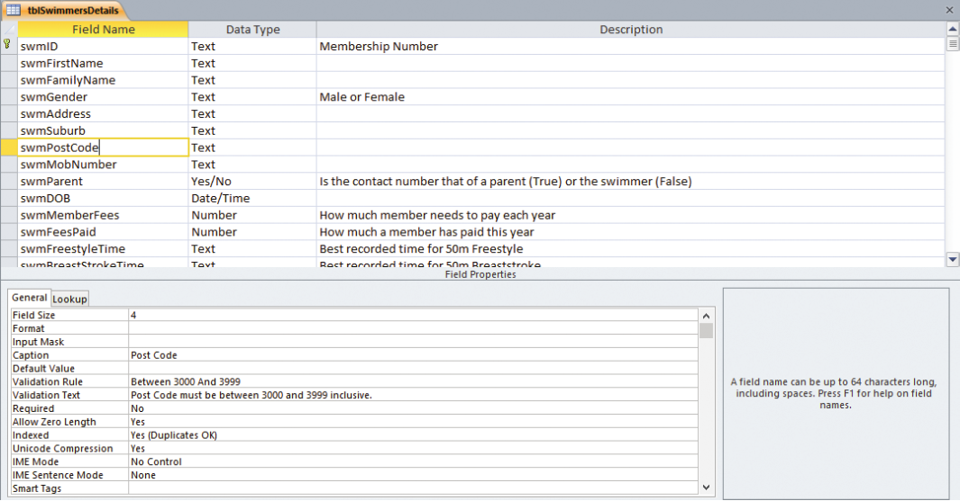
- What does the validation rule applied to the swmPostCode field tell you about club membership rules? (2 marks)

- What would happen if a postcode of 4444 were entered into this database? Explain why. (2 marks)

- If no postcode were entered for a member, what would the database do? Explain why. (2 marks)

Question 4
- What output would the following pseudocode produce? Use desk checking/ trace table to show your working logic. (4 marks)

BEGIN
A ← 7
IF A <= 7 THEN
A = A * 2
END IF
DISPLAY A
END

- What output would the following pseudocode produce? Use a desk checking/ trace table to show your working logic. (6 marks)

BEGIN
A ← 10
WHILE A >= 1
DISPLAY A
A = A – 2
END WHILE
DISPLAY “END”
END

Question 5
- Explain the difference between validation and testing using examples.
(3 marks)

- Explain the importance of indenting code and give an example of where it would be used. (2 marks)

- Explain why internal documentation is used in coding. (2 marks)

- Explain the purpose of using either Hungarian notation or CamelCase when naming objects in a program. Give an example to assist your explanation.
(2 marks)

- What is an array and how is an index used with an array? (3 marks)

Question 6
The following data contains two test marks for six different students over the semester.
Student | James | Sally | Jessica | Tracey | Billy | Andrew
Test 1 | 60% | 90% | 77% | 67% | 40% | 70%
Test 2 | 65% | 51% | 77% | 72% | 87% | 68%

- Using the data, create a visualisation that clearly displays the data’s main trends or patterns. (5 marks)

- Describe three conventions that you have used in your data visualisation and the reasons for their use. (3 marks)

Question 7
List and describe three tips for creating an effective user interface (UI).
(10 marks)

Question 8.
Explain each of the following types of coding errors: (6 marks)
- Syntax error:

- Logic error:

- Runtime error:

Question 9.
List and explain four measures to judge the integrity of data: (8 marks)

Question 10
Identify one advantage and one disadvantage for each of the following data collection techniques: (6 marks)
Survey – advantage:

Survey – disadvantage:

Interview – advantage:

Interview – disadvantage:

Observation – advantage:

Observation – disadvantage:

End of Exam
Spare page

