STUDENT NAME ________________________________

2012

Information Technology (Unit 1)

Liam O’Grady

WRITTEN EXAMINATION

Date | Tuesday the 19th of June
Reading Time | 1:35 – 1:40
Writing Time | 1:40 – 3:05
Total Writing Time | 1 Hour and 25 Minutes

Instructions:
Section A. 15 Multiple choice questions worth 15 Marks in total
Section B: 10 Short answer questions worth 40 Marks in total
Overall total: 55 Marks

* No talking is permitted during an examination.
* Students are permitted to bring into the pens, pencils, highlighters, erasers, sharpeners and rulers.
* Students are NOT permitted to bring blank sheets of paper and/or white out liquid/tape
* Students are NOT permitted to bring mobile phones, ipods and/or other electronic communication devices into the room.
* No calculator is allowed in this examination
* All material must be handed in at the end of the examination.

SECTION A – Multiple Choice Questions

Instructions for Section A

Answer all questions by circling the correct answer.
Choose the response that is correct or that best answers the question.
A correct answer scores 1; an incorrect answer scores 0.
No marks will be given if more than one answer is completed for any question.

Question 1
The four stages of the problem solving methodology are:
A. Analyse, Design, Develop, Evaluate.
B. Analyse, Solution requirements, Solution constraints, Scope of solution.
C. Analyse, Design, Manipulate, Test.
D. Design, Develop, Test, Evaluate.

Question 2
A detour sign near roadworks is there to:
A. Inform.
B. Persuade.
C. Educate.
D. Entertain.

Question 3
The best tool to represent the appearance of a website is:
A. A layout diagram.
B. A mockup.
C. A site-map.
D. An IPO chart.

Question 4
The best transmission media to connect two countries together is:
A. 3G
B. UTP
C. Fibre-optic
D. Super-fast streaming cable

Question 5
Creative Cars has created a spreadsheet to show graphs of their car sales. The best measure of how efficient their spreadsheet is would be:
A. How attractive the graphs are.
B. Whether or not they have included all necessary information.
C. Whether the graphs save them time.
D. If the graphs clearly communicate the information.

Question 6
What type of network do we have at school:
A. Client-server.
B. WAN.
C. LAN.
D. Wireless.

Question 7
Which of the following is not a transmission medium?
A. 3G.
B. Bluetooth.
C. TCP/IP.
D. Fibre-optic.

Question 8
Which of the following is not an advantage of using a network?
A. User dependence.
B. Sharing software.
C. Sharing hardware.
D. Sharing data and information.

Question 9
The main purpose of a firewall is to:
A. Keep the network administrator warm.
B. Protect your network from external attacks.
C. Protect against viruses in your network.
D. Filter out spam.

Question 10
An example of the character data type is:
A. ‘character’
B. ‘Prashanth’
C. ‘g’
D. ‘71’

Question 11
Primary data is:
A. Data acquired from primary school children.
B. Data acquired from Wikipedia.
C. Data acquired directly from stakeholders.
D. Data of the utmost importance.

Question 12
Yoga for life is a small yoga studio in Brunswick. They are thinking about storing all their data on the cloud. An advantage of this is:
A. Rain will keep the data clean.
B. Privacy is guaranteed.
C. Cloud computing cannot be hacked.
D. They do not need to worry about backups.

Question 13
A basic precaution to take when using E-Commerce is:
A. Lock up your computer when you are not using it.
B. Always use an internet café as they are more secure.
C. Check you have an https connection when transmitting credit card details.
D. Use a false identity.

Question 14
Sarah has been sent threatening messages via MSN and SMS. The best action to take is:
A. Delete all messages sent. Eventually they will get bored and stop.
B. Save all messages as evidence and report the matter.
C. Attack back to make them stop.
D. Change her phone number and stop using the computer.

Question 15
Which of the following is not a symptom of computer addiction:
A. Users craving computer time.
B. Users neglecting family and friends.
C. Users being unable to stop computer activities.
D. Users developing online friends.

SECTION B – Short Answer Questions

Instructions for Section B

Answer all questions in the spaces provided.

Question 1– source OGR
Explain the difference between effectiveness and efficiency. Give an example for each.

(4 Marks)

Question 2 – source OGR
List three data types and give an example of each.

(3 Marks)

Question 3
Brunswick Secondary College has decided to shift to using cloud computing.
- What is an advantage of cloud computing for them? Justify.

(2 Marks)
- What is a disadvantage of cloud computing for them? Justify.

(2 Marks)

Question 4
Creative kids is a daycare centre in Brunswick. They are creating a database to store details of all children that come to their daycare. They will be storing the gender, date of birth, name and address of all children.
- What data type should they use to store the gender? ________________
- What data type should they use to store the address? _______________
(1+1 Marks)

Question 5
Cheap Tix is a company that sells cheap tickets to major attractions. They have recently created an online ordering system where customers will be able to select an event, input how many tickets they wish to order and then pay for them.
- What validation should they have on the events and why?

(2 Marks)

- What validation should they have on the ticket numbers and why?

(2 Marks)

Question 6
The Book Nook is a tiny bookstore in Coburg. They have a small computer network in store to help manage their sales. There is one computer at the sales counter and two out in the back office. All computers are networked together. They wish to connect their network to the internet but are worried about security.

- List three measures they should take to protect their network. Justify each measure.

(6 Marks)
Question 7
The Cheetahs are a local running club. You have been hired to create a website for them. They wish to have information about social gatherings, running track, results and future races on their website.
- Draw a layout diagram for their website.

(4 Marks)
- Why would it be a good idea to create a Mockup of this website?

(1 Mark)
- At what stage of your website creation will you do the testing?___________
(1 Mark)

Question 8
Bunyip College is a large school situated in the fine city of Waterhole. Due to some problems with security they have recently installed a firewall to protect their network.
- How will the firewall protect their network? Give an example.

(2 Marks)
- What is a disadvantage of only having a firewall to protect their network? Give an example.

(2 Marks)
Question 9
The following is a design for the best ever webpage. Analyse the page in terms of the design elements.
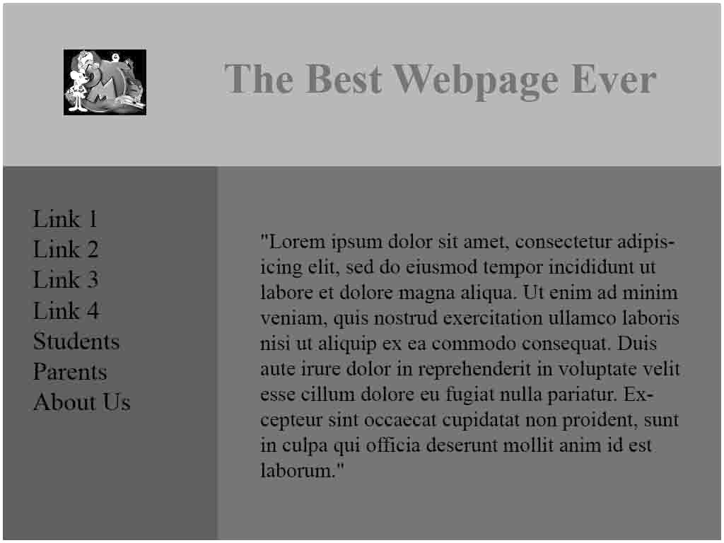

- Design Element: __________________
Explanation of how it has been used.

(2 Marks)

- Design Element: __________________
Explanation of how it has been used.

(2 Marks)

Question 10
The Magic Shop at Hogwarts sells crystals to young witches and wizards. A picture of the spreadsheet they use is below:
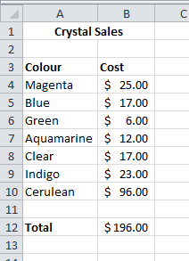

- What is the most efficient formula they could have in cell B12 to calculate the total?
(1 Mark)
- What formula could they put into cell B13 to calculate the highest cost.
(1 Mark)
- Once they add that formula to B13 what should they do to enhance the effectiveness of their spreadsheet?

(1 Mark)

