Santa Maria College



Year 11 Information Technology

Unit One Examination

Thursday 12th June, 2008

Student’s Name _________________________

Teacher Mr Golub Class 11 _________

Reading Time 11:45 – 12:00 (15 Minutes)
Writing Time 12:00 – 1:30 (1.5 hours)

Instructions:
Answer all questions
Answer in as much detail as possible
Use blue or black pen

Multiple Choice = 20 Marks

Short Answer Questions = 130 Marks

Total Marks = 150 Marks

Score________ / 150 = Grade _________%

SECTION A: MULTIPLE CHOICE
Clearly circle the letter of best alternative, if you are not sure take your best guess.

- What is the C.P.U. in a computer?
  - The main Processor
  - The hard drive
  - C - drive
  - Floppy disk drive
- A site map, or a linkage plan is:
  - A written plan of how each page of the website links together
  - A physical representation of how each page of the website links together.
  - A graphic representation of how each page of the website links together.
  - A textual representation of how each page of the website links together.
- Data integrity is the degree to which:
  - Data is correct
  - Data is processed
  - Information is manipulated
  - Information is processed
- Which of the following is an output device:
  - Keyboard
  - Printer
  - Microphone
  - Scanner
- Which of the following statements best describes how information technology has allowed improvement in efficiency:
  - Tasks take less time, higher costs, more effort.
  - Tasks take less time, lower costs, less effort.
  - Tasks take more time, lower costs, less effort.
  - Tasks take less time, higher costs, more effort.
- Two common web browsers are:
  - Netscape and PowerPoint
  - Windows and Internet Explorer
  - Netscape and Internet Explorer
  - Explorer and Web Browser
- For information to be credible it should be:
  - Authoritative, current, cultural content
  - Informative, persuasive, entertaining
  - Reliable, meaningful, accurate
  - All of the above
- Which of these reflects the structure of a database?
  - Databases contain tables which contain reports which contain fields
  - Databases contain tables which contain records which contain fields
  - Databases contain queries which contain fields
  - Databases contain data in either records or tables, depending on the design
- Formats and conventions are:
  - Guidelines which apply to the presentation of output
  - Rules which determine the use of colors
  - Correct methods of implementing a web site
  - Correct methods of setting out designs
- Good web page design should NOT include the following:
  - An identity logo placed on individual web pages
  - Internal links aligned along the left and/or bottom of the page
  - Different colour themes for individual pages of the website
  - A limit of no more than three screens of information per web page
- Data gathered for processing into information should be:
  - Free of errors and free of bias
  - From a source with a vested interest
  - From a small sample to make it manageable
  - Reliable and with a timely format
- You should not knowingly publish misleading or false information on a web site because:
  - Copyright laws
  - Privacy laws
  - Computer viruses
  - Computer ethics
- Data can be described as:
  - An opinion
  - Well presented and organised material fed to a computer for storage
  - Raw unorganised facts fed to a computer for processing
  - The storage pictures and stories
- Which one is NOT a characteristic of an audience?
  - Special needs
  - Gender
  - Religion
  - Education level

- Qualities of effective information should be:
  - Reliable, complete, accurate and well presented
  - Effective, timely, accurate, unbiased
  - Efficient, effective and unbiased
  - Valid, reliable and timely
- Which one of the following is NOT a design tool?
  - IPO chart
  - Flow chart
  - Layout diagram
  - Mission statement
- Anti-virus software is an example of which kind of software?
  - Application
  - Utility
  - Operating system
  - Desktop Publishing
- What do the letters ISP stand for:
  - Intelligent Service Protocol
  - Internet Service Provider
  - Insane, stupid person
  - Information Service Provider
- Which of the following is NOT an example of a secondary source of data?
  - Measurement
  - Internet
  - Newspaper
  - Radio show
- Information is said to be biased when:
  - It has not yet been processed properly
  - The results tend to lean towards only one point of view
  - You can’t collect enough surveys to get good results
  - All questions on a survey are equally weighted in importance

(20 marks)
- The information processing cycle is used to convert data to information.
    - In the table provided below list the nine Information Processing phases, in order.
    - Explain each phase.
Phase | What happens during that phase

(9 x 3 = 27 marks)
- List and explain two qualities that data must have to be useable.
1.
2.
(4 marks)
- Information is used for four main purposes. What are they?
(2 marks)
- Indicate whether the following software products are examples of operating systems or applications software.
Windows 98
Lotus 123
PowerPoint
DOS
Netscape Navigator
(5 marks)
- What two ways can data be validated?
(2 marks)
- List any four criteria, which affect the quality of information.
(4 marks)
- What symbol would you use to indicate a decision when making a flow chart?
(1 marks)
- Name two search engines.
(2 marks)
- Explain what is meant by the term Ergonomics.
(3 mark)

- Explain the difference between data and information.
(2 marks)
- Why should you perform regular backups?
(1 marks)

- Explain three issues associated with the use of information and communication technology.
1. | 3.
2.
3.
(3 x 2 = 6 marks)
- The Digital Divide separates individuals into two main categories. Briefly describe the two different categories.
(4 marks)

- Choose the word – efficiency or effectiveness – which best relates to the descriptions given below
  - A high quality printout is an example of:
  - A cheap, lower quality pamphlet produced in bulk is an example of:
  - A clear and accurate sales report for an organization is an example of:
  - A barcode scanner which saves time at a supermarket checkout is an example of:
(1 + 1 + 1 + 1 = 4 marks)

- What is the function of an input device?
(2 mark)
- Give two examples of input devices not including keyboards and computer mouse(s).
(2 marks)
- What is the function of an output device?
(2 mark)
- Give two examples of output devices not including a printer or monitor.
(2 marks)
- In the spaces below, list four different types of data and provide one example of each.
Data type 1 | Example 1
Data type 2 | Example 2
Data type 3 | Example 3
Data type 4 | Example 4
(2 marks)
- Explain the difference between primary storage and secondary storage and include reference to where data is stored in your answer.
(4 marks)

- Jasmine Fox wants to buy a new computer to create web pages, calculate statistical data and produce slides for oral presentations. List any two pieces of software will she need to buy to have her computer working and performing all these tasks?
(2 marks)
- Name three characteristics, which can cause data to be biased.
(3 marks)
- In the space below create a flow chart using appropriate symbols – input, decision, process, start, and finish – to demonstrate the following procedure of making a cup of coffee.

  - Start
  - Get coffee, cup, milk & sugar
  - Input coffee in cup
  - Input water into kettle
  - Boil water
  - Is water boiled?
  - Input boiled water in cup
  - Input milk
  - Input sugar in cup
  - Stir ingredients
  - Is coffee sweet enough?
  - Drink coffee
  - End

(5 marks)
- The East Westbury Primary School has produced the following flyer for their annual concert. Make suggestions as to how this flyer could be made more effective.
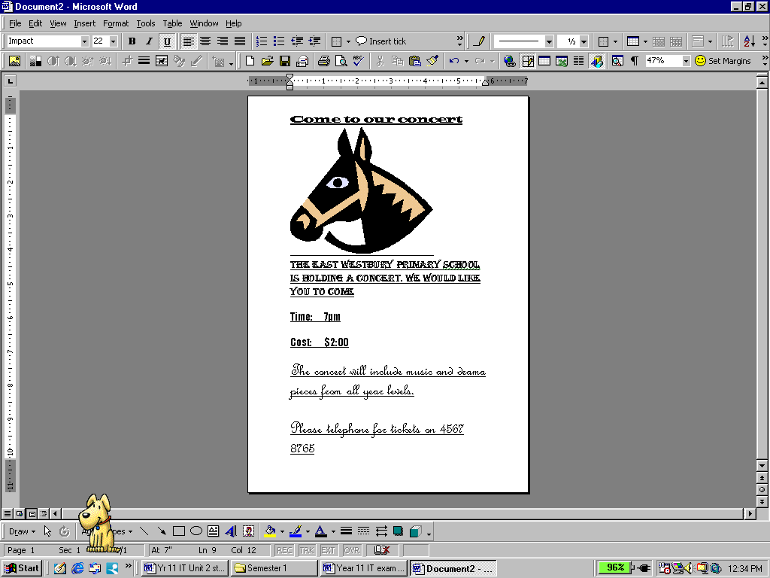

1.
2.
3.
(6 marks)
- Information problems and outputs are usually the result of applying a problem-solving methodology.
    - In the table below write the name of the correct step of the problem-solving methodology with its appropriate description
Test Document Analyse Implement Develop Design Evaluate
STEP |  | DESCRIPTION
 |  | Write instructions for the users of the solution so that they know what to do
 |  | Acquire feedback about how successful or otherwise the solution is to help you decide if changes need to be made to the solution
Create appropriate test data to ensure that the solution works correctly
Draw what the final solution output will look like on paper
 |  | Study the problem carefully and look for alternative solutions
 |  | Give the final solution to the customer to have them put it onto their system
 |  | Try out the solution now that you have finished it to see how it works before you give it to the customer.
 |  | Create the solution using appropriate software
(7 marks)
- When is the best time to do evaluation?
(2 marks)
- During which phase is dummy data determined?
(1 marks)
- Match the following terms with their correct meaning:
Software piracy | Unauthorised access | Intellectual property
Information privacy | Copyright | Licence agreement
Site licence | Hacker | Code of conduct

Place correct term from above list here | Meaning
 | Refers to original work created by inventors, authors and artists
 | Gives authors and artists exclusive rights to duplicate, publish and sell their material
 | The unauthorized and illegal duplication of copyright software
 | A written guideline that helps determine whether specific use of a computer is ethical
 | The use of a computer without permission
 | Someone who tries to access a computer without permission
 | Provides specific conditions for the use of software
 | Gives the buyer the right to install the software on multiple computers at a single site.
 | Refers to the right of individuals and companies to deny or restrict the collection and use of information about them
(9 marks)

- Explain three conventions or formats that are applied to the layout and presentation of output.
1.
2.
3.
(3 x 2 = 6 marks)

- Explain if and how the copyright laws have been considered in the following examples:

- Jason copies an explanation that he found on a website into his essay and hands it in for assessment.
YES or NO
Why?
- Peter copies an explanation that he found on a website into his essay. He places it in quotation marks and cites the name of the author, the website and URL and the date it was last updated before handing it in for assessment.
YES or NO
Why?
- Joanne has borrowed the latest CD from a girlfriend with a view to making a copy of it. She cannot afford to buy the CD, so she makes a copy for use in her car.
YES or NO
Why?

(2+2+2 = 6 marks)

End of exam

