HAILEYBURY

GENERAL MATHEMATICS F - UNIT 1, 2004

EXAMINATION 2 - ANALYSIS TASKS

Student Name..............................................

Teachers Name.............................................

INSTRUCTIONS

Reading time: 15 minutes
Writing time: 90 minutes

Question | 1 | 2 | 3 | 4 | 5 | TOTAL
Marks | 13 | 14 | 31 | 9 | 8 | 75
Subtotal

Directions to students
You must attempt all questions and write your answers in the spaces provided.

A graphics calculator may be used.

You may bring to the examination four pages (two A4 sheet) of pre-written notes.

- Applications of Arithmetic [13 marks]

A particular junior college had 70 Year 7’s, 60 Year 8’s, 80 Year 9’s and 70 Year 10’s.

- Express the number of students at each year level as suitable ratio.

[2 marks]

The Year 8’s decided to have a cake stall to raise money for the local hospital and managed to make a profit of $392. Not to be out-done, the other year levels decided that they too would donate exactly the same amount.

The Year 7’s decided that they would simply get each student at their year level to donate an equal amount so that their total would be $392

- How much would each Year 7 student donate?

[1 marks]

- The Year 9’s decide that each student will donate $2 and the rest will come from the profit of a sausage sizzle.
  - How much profit must be made at the sausage sizzle in total?

[2 marks]

  - If they make a profit of 40 cents on each sausage sold, how many sausages must they sell?

[2 marks]

- The Year 10’s decide to buy boxes of chocolates direct from the manufacturer and sell them at a profit of 20% of the cost price, with all the profit going to the hospital.
  - What is the total cost of the boxes of chocolates needed to make a profit of $392?

[3 marks]

  - If each box costs $2.80, how many boxes do they need to buy?

[1 marks]

  - How much will each box need to be sold for in order for the required profit to be made? (give your answer in exact dollars and cents, do not round off to the nearest 5 cents)

[2 marks]

- Linear Relations and Equations [14 marks]

A rectangular lawn is twice as long as it is wide. The length of the perimeter is 54 metres.

- Draw a diagram to represent the lawn. Clearly define the variable(s) used.

[2 marks]

- Find the length and width of the lawn?

[3 marks]
- A path of width 1 metre is to be placed around the lawn. Find the area of the path.

[3 marks]

Ann bought 4 hamburgers and one can of drink and paid $14.40. Jim bought 5 hamburgers and 7 cans of drink and paid $27.20.

- Set up a pair of simultaneous equations, clearly defining your variables.

[2 marks]

- Find the cost of one hamburger and one can of drink.

[4 marks]

3. Statistics [31 marks]

The following list gives the English and History marks for each student in a particular form.

English (x) | 65 | 60 | 92 | 65 | 75 | 30 | 50 | 58 | 62 | 58 | 85 | 70 | 57 | 35 | 62
History (y) | 60 | 51 | 89 | 69 | 80 | 12 | 45 | 64 | 55 | 61 | 77 | 52 | 37 | 40 | 69

a) Using your graphics calculator, complete the table of summary statistics for the two subjects. (Give answers to the nearest whole number.)

 | English | History
Mean
Q1
Median
Q3
Minimum score
Maximum score
IQR
Range

[8 marks]

b) Showing all working, find any outliers for each subject.

[3 marks]

c) Draw parallel box plots for the two subjects.

[6 marks]
d) Discuss the centre, shape and spread of the distributions of marks in the two subjects.

[3 marks]

- For the fifteen students, in which subject did the class perform better?

[2 marks]

- Now, draw a scatter plot showing the relationship between English and History:

English (x) | 65 | 60 | 92 | 65 | 75 | 30 | 50 | 58 | 62 | 58 | 85 | 70 | 57 | 35 | 62
History (y) | 60 | 51 | 89 | 69 | 80 | 12 | 45 | 64 | 55 | 61 | 77 | 52 | 37 | 40 | 69
(y) History

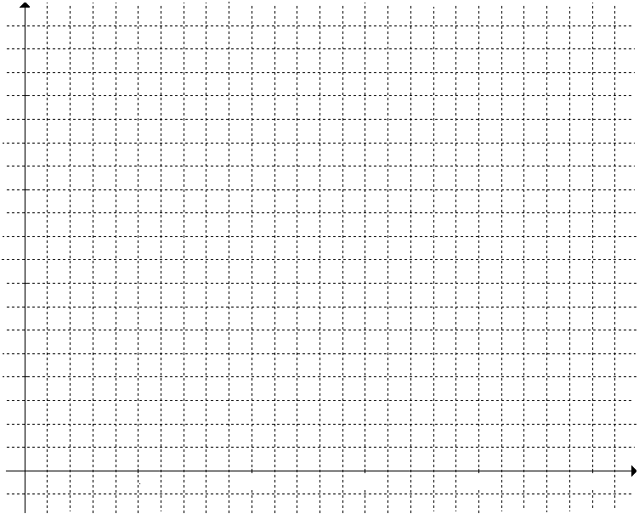
(x) English

[4 marks]

- Use your calculator to find the “Least Squares” regression line. (Give your answer with constants correct to 2 decimal places.)

[2 marks]

- Draw the regression line on the scatter plot. Clearly label two points on the line.

[3 marks]
4. Coordinate Geometry [9 marks]

Jessica starts at home, H (0,2) and walks to the shops, S (3, 5). From the shops she then goes directly to the park, P (6, 3).

a) Draw a diagram representing her journey on the axes provided:

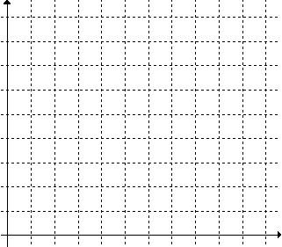
[2 marks]

b) If Jessica wishes to return home directly from the park, P to her home H, what distance will she have to travel?

[2 marks]

c) Find the equation which describes the path Jessica will have to follow from the park P to home H.

[3 marks]

d) Jessica drops her mobile phone exactly half way between the shops and the park. What would be the coordinates of where her mobile phone could be found?

[2 marks]
5. Sequences and Series [8 marks]

At the beginning of this year Linus inherited his uncle’s collection of 750 Phantom comics. Starting next year, Linus will also receive a parcel of 30 comics, each year, by subscription.

a) Give the rule for the expected number of comics Linus will have at the start of each year.

[2 marks]

b) How many comics will Linus have by the beginning of his 5th year as a comic collector?

[2 marks]

c) At the start of which year will he have 990 comics?

[2 marks]

d) Linus has just discovered that Phantom Comics are a valuable collectors item. He attended a Comic Convention and they valued his comics to be worth $3000. They also told him the value of the collection would increase at a rate of 3% per annum.
If Linus did not add any more comics to his uncle’s collection of 750 comics, what would they be worth in five years time? (Answer to the nearest cent.)

[2 marks]

