Creating a site
Login to Microsoft Office Home (office.com)

Click on Menu

Click on SharePoint

Click Create site
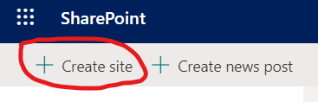

Choose Team site

Give the site a name. I recommend YEAR SUBJECT CLASS
Eg 2021 Web Development 10A

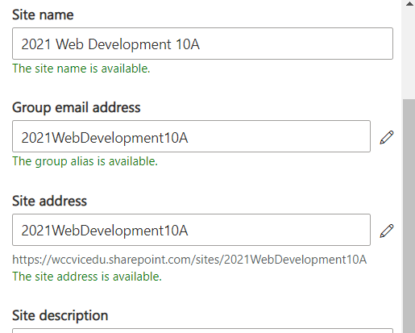
,
Next

Add any other teachers as owners - for me this is usually blank

Add students as members - start typing their names and suggestions will pop up ( a bit of a slow process)

For privacy reasons I will just use the Test Student not an actual student

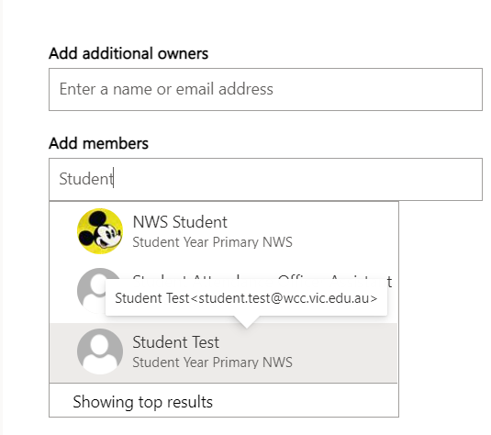
Do this for all your students

Click Finish

Because this is to be a Class SharePoint members are not given rights to the main document area. Students will have full access to their own folder and read_only to a general folder.

Click on Documents (You may have to click on documents twice for the next menu to appear)

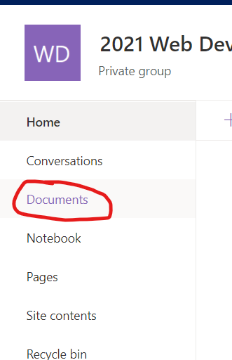

Click on Settings and then Library Settings

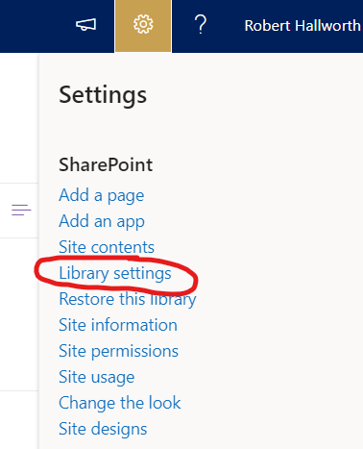

Click on Permissions for this document Library

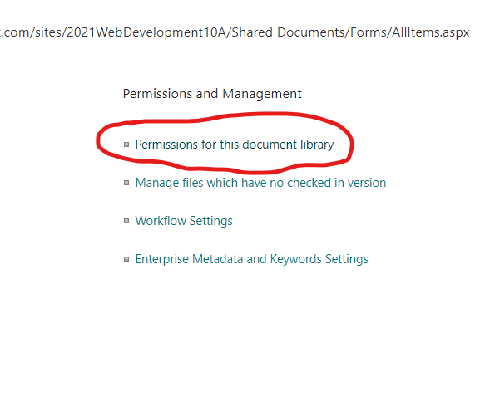

Now Stop Inheriting Permissions

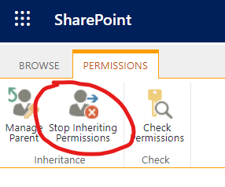

Now we need to remove the members edit rights to the root directory. This will prevent students from creating folders in the root directory.
Click on the members group then click Edit Users Permissions

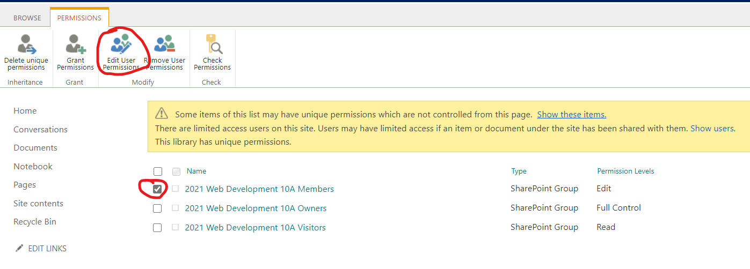

Set rights to Read and remove the edit right

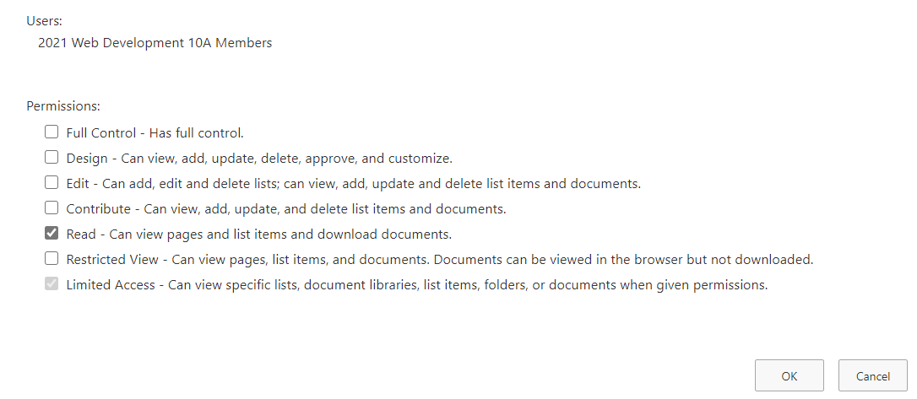

Now back to Documents

Creating a General shared folder

Click New Folder to make a folder called General. Click create.

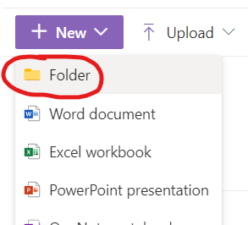

Click to the left of General to select it

Click on show actions and choose Manage Access

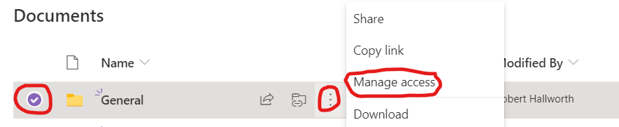

Change Members access to can view. This should be set already.

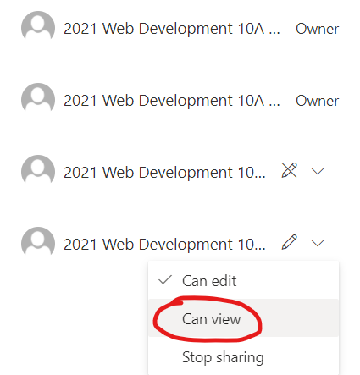

Creating Student Folders
Now create the individual Student folders as Surname_Firstname so they will be sorted by surname. Join name with an underline.

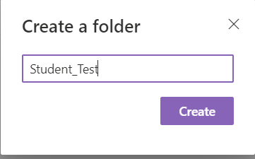

Again tick folder and manage access

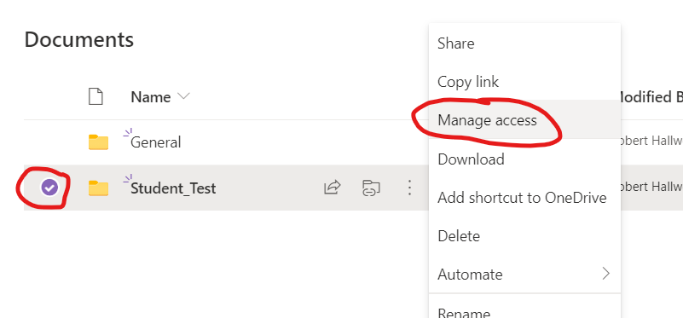
Now stop sharing with Visitors and stop sharing with Members
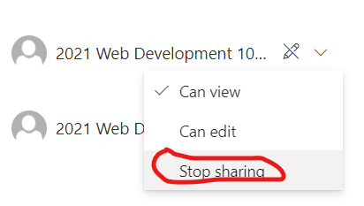

Do a direct access for the student by typing in their name

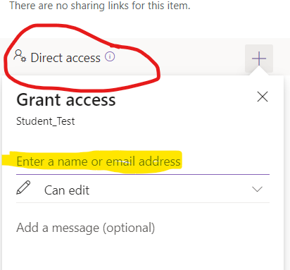

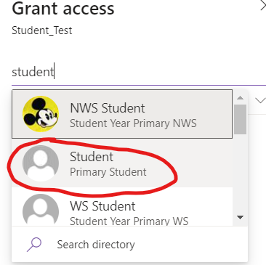

Set them to edit folder. I normally do not notify the student

Click Grant Access

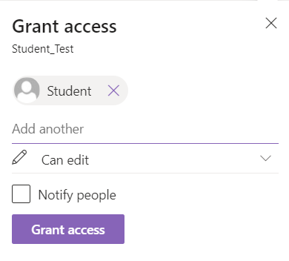
Repeat this for the remaining students in your class.

Sharing the Site using OneDrive
Click on home
And copy the URL for the site

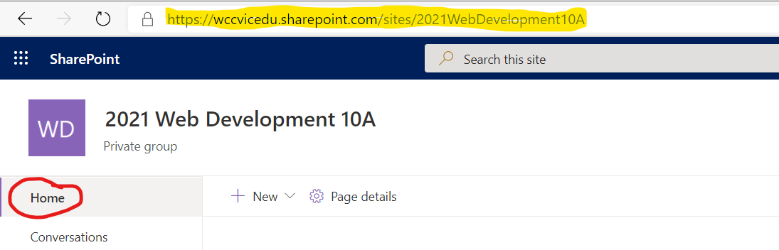
Email the URL for the site to your students.

Ask them to login to the site and click on Documents

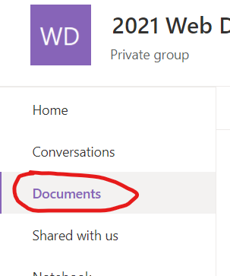

They will only see the General folder and their own folder. The teacher will see all the folders

Click sync

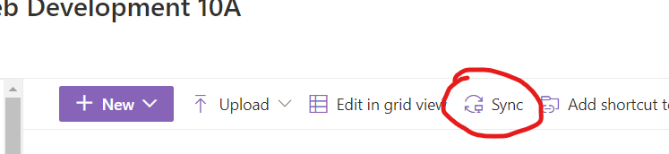

Click Open

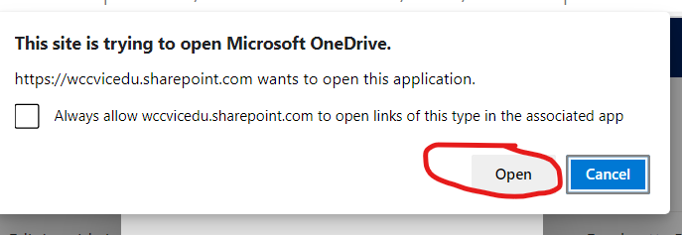

You should get a pop-up message like this

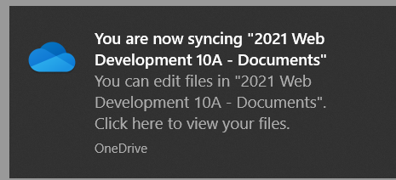

Now to fine your files. Open Windows Explorer

Scroll down you should see the schools site folder with a building icon and listed inside that the site you have created.

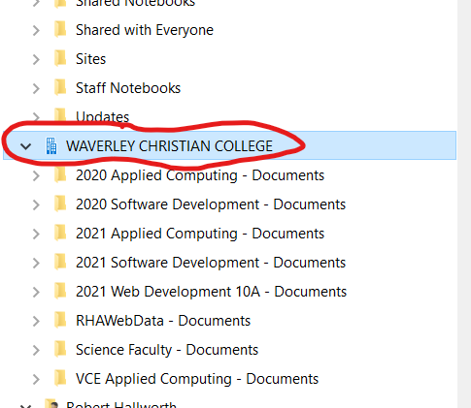

Students can click on the site folder and see their own folder plus general. Staff can see and edit all folders.

