Student Number:

Software Development
U4O2 SAC

Written Assessment
Monday 16th September 2018

QUESTION AND ANSWER BOOK

Structure of book
Sections | Number of questions | Number of marks | Total marks
Section A: Multiple Choice | 10 | 5 Marks Each | 50

Materials:
- Question and answer book of 14 pages.
- Pen/pencil

Instructions
- Ensure your student name / number are correct.
- All written responses must be written in English.

Software Development
SAC: Unit 4 Outcome 2
2018

Analyse and explain the dependencies between two information systems and evaluate the controls required in information systems to protect the integrity of its source data.
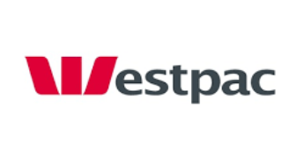
In an effort to encourage Melbourne people to bank with them, Westpac has decided to offer free PTV travel for all customers on weekends. To qualify for the free travel, customers must apply for a Westpac Myki card. This smart card can be used on any public transport in Victoria but is linked to the Westpac customer’s bank account – allowing them to directly charge their accounts for all travel during the week. The card also provides Westpac with the opportunity to use the travel data to customise promotional material to customers.
Public Transport Victoria is always looking for a way to cut costs in delivering their service. Westpac has agreed to pay for the cost of all Westpac customers on weekend travel and the production of special Westpac Myki cards in return for the travel data of the Westpac customers. The program is also adding value to their own public service announcements and advertising which costs them over $200, 000 a year.
PTV collects the following data from Myki cards:
- Touch on station/tram/bus stop location at start of journey
- Touch off station/tram/bus stop location at destination
- Card Type: Full Fare/ Children / Concession/ Seniors
- Top up amount in $AUD

Westpac collects a great deal of personal data from customers to ensure they can have an account. They also collect a lot of data about what customers spend their money on when they use their debit cards or credit cards at EFT POS (Electronic Funds Transfer Point of Sale). Westpac is interested in knowing more about their customers and how they use public transport so they have decided to implement this program to collect information about customer movements. The outcomes of which will provide Westpac with data that can identify the customers they can target for insurance, car and home loans. For example: if a customer is travelling via public transport everyday across town to work, they could be targeted for special home loans that might suit their budget and meet the property prices of the location where they work.
Westpac collects the following data from customers:
- Name, address, phone number
- Work details
- Income details
- Budget habits
- Purchasing details
- Account Balances

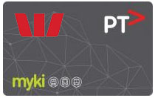
The proposed system will use a Smart Card that will store the customer’s identification data with the same method as a credit card. The card can be used in Westpac ATMs to load more funds.
The card can be also used to “Touch On” and “Touch Off” all Melbourne public transport. All locations where the card is used will be logged and stored on the card. The card recalculates the balance and the new balance is stored on the card.
When a card is used on public transport it is swiped on the “Bus Ticket Registration Port” (BTRP) which logs the beginning of your journey onto the card. When the card is swiped at the destination the BTRP logs the destination and recalculates the balance based on the journey length.
When the card is entered into a Westpac ATM all travel data (including the beginning and ends of each journey) is updated in the customer account with the Westpac databases.
Westpac Marketing Analysts have access to this data to mine for potential customers who would consider new financial products such as home loans. Analysts can investigate travel habits and buying habits to make decisions about which customers would be invited to participate in special offers.

The Westpac – PTV Travel System Cart Network Diagram

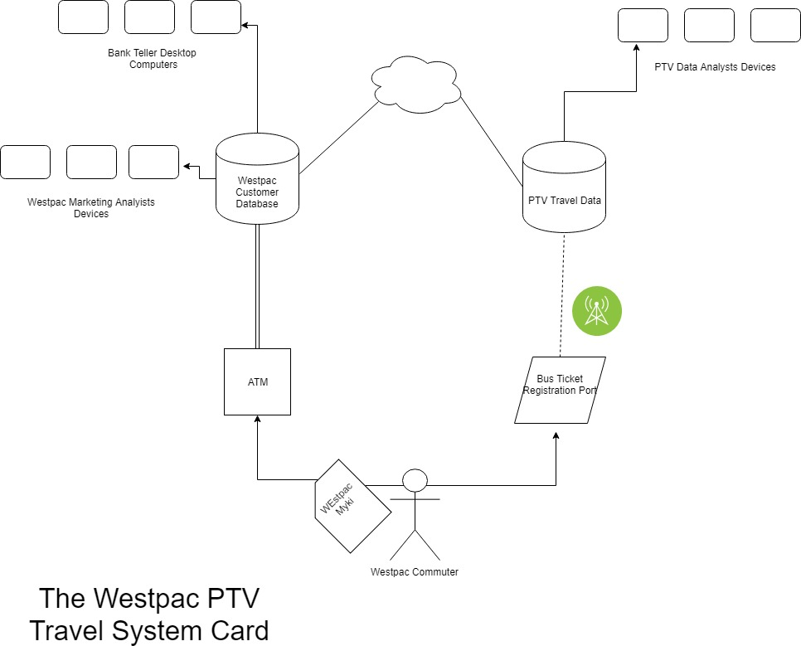

Report on how legal obligations and data management affect the ability of the information systems to meet objectives for the Westpac-PTV Travel System Card. Complete all the questions below based on the Case Study SPECIFICALLY and the Network Diagram provided.
Question 1
Describe the interactions that would occur within the PTV Myki card system for all PTV travellers.
[Criteria: Technically correct terminology is used to describe the networked environment and describe the interactions generated by information systems.]

PTV – Myki card system interactions include:
- Card purchase – type (adult/child/senior) and balance is purchased
- Customer touches “ON” Smart Card registers journey START from the BTRP.
- Customer touches “OFF” Smart Cart registers journey END and calculates the cost of journey
- Cost of journey is deducted from Smart Card balance
- Journey information is identified through network to register at BTRP
- Journey information is collected at BTRP and sent back to PTV system.

5 Marks

Question 2
Describe the interactions that occur within the Westpac Banking system for all banking customers.
[Criteria: Technically correct terminology is used to describe the networked environment and describe the interactions generated by information systems.]

Westpac banking interactions include:
- Customer account creation where all personal and financial details are collected and stored. This may include credit history and work place details.
- Depositing funds from work place or directly are recorded in customer account and balance adjusted
- Withdrawals from purchases (Direct debit or credit card) or from ATM/Teller direct withdrawals are recorded in customer account and balance adjusted
- Each purchase using the card stores transaction details including the store, the location and purchase price.
- Bank Statements are generated and sent to customers summarizing the transitions each month
- Balance checks via online access or, app access to accounts are also recorded.

5 Marks
Question 3
Describe the interactions between PTV and Westpac.
[Criteria: Technically correct terminology is used to describe the networked environment and describe the interactions generated by information systems.]

PTV – Westpac interactions include:
- Balance top-up via ATM stores new balance on Smart Card so it can be used on PTV transport
- Touching on and off PTV stores location journey data on the Smart Card
- When the card is returned to ATM machine all journey data is transferred to the Westpac Servers for analysis
- Westpac needs to pay for free weekend travel so all weekend journey information needs to be collected and paid to PTV.

5 Marks

Question 4
Describe required data management practices at Westpac to ensure data integrity.
[Criteria: All techniques to identify causes of conflict and thorough evaluation of the organisation’s data management practices]

Westpac Data Management Practices required include:
- When accounts are set up all personal information needs to be confirmed by the customer to ensure the contact details are correct.
- To ensure only the account owner has access to the fund, a password and PIN are created to limit to authorized access only.
- Personal information needs to able to be updated if address, etc. changes
- Validation at ATM transition should require confirmation of the customer that withdrawal/deposit amounts are correct.
- Each transaction must generate a receipt/email/sms.
- Lost or stolen cards must be able to be cancelled in a timely manner.
- Guidelines for Westpac staff on accessing customer data.

5 Marks

Question 5
Describe required data management practices at PTV to ensure data integrity.
[Criteria: All techniques to identify causes of conflict and thorough evaluation of the organisation’s data management practices]
PTV – Myki card system Data Management Practices required include:

- When customer uses the BTRP there needs to be validation to show the user that the card has been successful in touching on or off.
- At the end of a journey new balance is displayed on BTRP to provide feedback to customer.
- Providing accurate location data can be collected from a GPS system or a PTV location network.
- Enforcing Myki cards are used by having Traffic Wardens pren\sent to check cards of customers travelling

5 Marks

Question 6
Describe what situations might influence the integrity of the data on the card.
[Criteria: Comprehensive description of data integrity characteristics and a very detailed description of the impact of diminished data integrity]

Situations that might influence data integrity include:
- Card type (adult/senior/child) may not be correctly purchased for the customer. This is collecting data for the wrong demographic.
- Card is used by a family member or friend – collecting data for the wrong person.
- Incorrectly touching “on” and “off” or failing to do so will result in incorrect data or missing data.
- Customers choosing not to use the ATM to top up card for long periods of time would result in data not being collected by Westpac in a timely manner – also how much data do Smart Cards hold – if the user puts a large amount of money to limit the number of time they have to top up – this might lead to the card holding too much data.
- Card damages/stolen/lost

5 Marks

Question 7
Explain how legislation will impact on how Westpac adds new customers to the scheme.
[Criteria: Insightful understanding and application of relevant legislation demonstrated in data management practices]

The impact of legislation includes:

The Privacy Act (1988) Australian Privacy Principles:
- APP 1 (the open and transparent management of personal information) and APP2 (the collection of solicited personal information ) requires this new scheme to explain the full nature of what data is being collected and for what purpose.
- APP 5 (Need to take reasonable steps to keep personal information updated) and APP 10(maintaining the quality of personal information) and APP 13 (right for individuals to access and correct their personal information) Customers of this scheme will require being given the opportunity to keep their data up to date.
- APP 11(keeping personal information secure) The scheme will need to keep all personal information secure.
- APP 7 (direct marketing) No customer personal information can be disclosed for direct marketing without consent.
The Spam Act (2003)
- Commercial messages cannot be sent without consent
- Any commercial message must be accompanied by an “unsubscribe” option.

5 Marks

Question 8
Describe what impact would be made if there is a diminished level of data integrity entered via the card?
[Criteria: Comprehensive description of data integrity characteristics and a very detailed description of the impact of diminished data integrity]

Impact of diminished data integrity includes:
- Travel data collected for a family member or friend or incorrect Touch ‘on’ and ‘off’ will result in the data collected for that account will not reflect the account holder’s actions. This can cause analysts conclusions to be incorrect. This can result in targeted marking offers to miss the mark and customers are offered financial products that are invalid for them. Unsuccessful marketing could result in customers “Unsubscribing” to the marketing emails while continuing to benefit from the free weekend travel.

- Incorrect Touch ‘on’ and ‘off’ will result in journey data being incorrect making any analytical conclusion incorrect. This can also result in customers being under charged or overcharged for travel. Customers then may choose not to continue with the scheme.

5 Marks
Question 9
How would you evaluate the objectives of the Westpac-PTV Card?
[Criteria: Thorough explanation of ways organisations secure data and information and critical evaluation of the extent to which information system objectives are met]

Evaluating the objectives of the proposed scheme could include:
- Interview the Westpac data analysts to see if it is easy to use
- Investigate if direct marketing is targeting the correct people by checking if financial product purchases coincide with marketing campaign.
- Observe people using the system and see how they use it on public transport
- Interview or survey customers or potential customers of the scheme to see if they are satisfied with offers they are receiving and if they are finding they are tailored to their needs.

5 Marks

Question 10
What security measures would need to be addressed in the development of the Westpac-PTV Card?
[Criteria: Thorough explanation of ways organisations secure data and information and critical evaluation of the extent to which information system objectives are met]

Westpac-PTV Card scheme security measure required include:
- All data servers are behind a firewall and protected from malware with anti-malware software that is kept updated.
- All server hardware is physically locate behind locked doors with only authorized personal access.
- All system analysts and Westpac tellers need unique UserIDd/Password access to the personal information of customers.
- All Westpac staff need to be familiar with policies and protocol on personal data management and security.
- All data transported between ATMs and accounts needs to be encrypted.

END F SAC
5 Marks

