**Software Development Unit 3**

**Multiple Choice – Answer sheet**

The Knox School

|  |  |  |  |  |  |  |  |  |  |  |  |  |  |  |
| --- | --- | --- | --- | --- | --- | --- | --- | --- | --- | --- | --- | --- | --- | --- |
| Student First name |  |  |  |  |  |  |  |  |  |  |  |  |  |  |
|  |  |  |  |  |  |  |  |  |  |  |  |  |  |  |
| Student Surname |  |  |  |  |  |  |  |  |  |  |  |  |  |  |

|  |  |  |  |  |  |  |  |  |  |  |  |  |  |  |
| --- | --- | --- | --- | --- | --- | --- | --- | --- | --- | --- | --- | --- | --- | --- |
| Teacher Name | M | R | S |  | H | A | Y |  |  |  |  |  |  |  |

|  |  |  |  |  |
| --- | --- | --- | --- | --- |
| **Instructions**  Only **PENCIL** is to be used.  For each question, put a **cross** through the response that is correct or that best answers the question.  If you make an error – **erase** the incorrect cross and clearly cross the new response.  If it **two responses** are crossed for the one question, **zero** will be awarded for that question.   |  |  |  |  | | --- | --- | --- | --- | | **A** | **B** | **C** | **D** | |

|  |  |  |  |  |  |  |  |  |  |  |
| --- | --- | --- | --- | --- | --- | --- | --- | --- | --- | --- |
| **1** | A | B | C | D |  | **11** | A | B | C | D |
| **2** | A | B | C | D |  | **12** | A | B | C | D |
| **3** | A | B | C | D |  | **13** | A | B | C | D |
| **4** | A | B | C | D |  | **14** | A | B | C | D |
| **5** | A | B | C | D |  | **15** | A | B | C | D |
| **6** | A | B | C | D |  | **16** | A | B | C | D |
| **7** | A | B | C | D |  | **17** | A | B | C | D |
| **8** | A | B | C | D |  | **18** | A | B | C | D |
| **9** | A | B | C | D |  | **19** | A | B | C | D |
| **10** | A | B | C | D |  | **20** | A | B | C | D |

**SECTION A - Multiple-choice questions**

|  |
| --- |
| **Instructions for Section A**  Answer all questions in **pencil** on the answer sheet provided for multiple-choice questions.  Choose the response that is correct or that best answers the question.  A correct answer scores 1, an incorrect answer scores 0.  Marks will not be deducted for incorrect answers. No marks will be given if more than one answer is completed for any question. |

**Question 1**

In a use case diagram, an eclipse represents:

1. An actor
2. An entity
3. A use case
4. A data flow

**Question 2**

An array is:

1. A file of records
2. A data structure o store files
3. A file that allows data to be manipulated easily
4. A data structure that allows data to be manipulated easily

**Question 3**

In the Open Systems Interconnections (OSI) model the physical layer represents how:

1. A connection to a communications medium can be started or stopped
2. A connection to the correct network is established
3. A connection to an application is established
4. A connection to the user is established

**Question 4**

For K ← 1 to 50

NewMember ← Person[K]

EndFor

In the above Pseudocode, Person is an example of:

1. A file
2. An array
3. A record
4. An array of records

**Question 5**

User documentation is prepared in which phase of the problem solving methodology?

1. Analysis
2. Design
3. Development
4. Evaluation

***The following pseudocode applies to questions 6, 7 and 8***

BEGIN

READ T

IF T>35 THEN

X←’very hot’

ELSE

IF T>25 THEN

X←’warm’

ELSE

IF T>20 THEN

X←’perfect’

ELSE

IF T<20 THEN

X←’cold’

END IF

END

**Question 6**

When converting the above algorithm into a program it would be best for other programmers if the program used

1. Meaningful variable names and internal documentation
2. Meaningful variable names and external documentation
3. Single letter variable names and internal documentation
4. Meaningful variable names and no documentation

**Question 7**

When the above algorithm was tested it was found that it did not provide the correct result when T=20. This was caused by a:

1. Logic error
2. Syntax error
3. Run time error
4. Compile time error

**Question 8**

Test the above algorithm with the value T=25. The variable X will contain:

1. ‘cold’
2. ‘warm’
3. ‘perfect’
4. ‘very hot’

**Question 9**

A small company uses two floors of a building for its office. A 24-port switch is used on each floor to connect all the computers on that floor. Each computer has a network card and is connected to the switch by cable.  
The topology used on **each floor** is

1. Bus only
2. Star only
3. Hybrid
4. A combination of bus and star

**Question 10**

Computer systems use protocols to communicate. A protocol that allows computers to communicate with the internet is:

1. HTTP
2. TCP/IP
3. BIOS
4. IP Address

**Question 11**

Assume A=1, B=2 and C=3. The statement that causes D to become true is:

1. If A>B and C>B then D←true
2. If B>A and B>C then D←true
3. If A>B or C>B then D←true
4. If A>B and B>C then D←true

**Question 12**

The two data types that best store the family name of a person, for example Smith, and their phone number, for example (03) 9999 9999, are:

1. Number and Time/Date
2. Number and String/Text
3. String/Text and Time/Date
4. String/Text and String/Text

**Question 13**

A variable is required to store a true/false value. The best data type for this variable is:

1. Number
2. Boolean
3. String/Text
4. Time/Date

**Question 14**

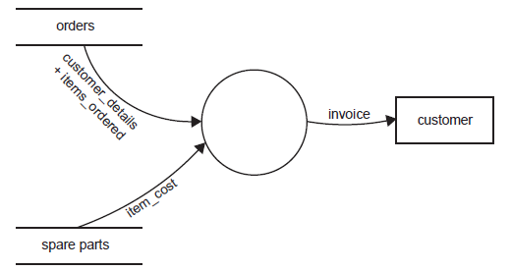

Which statement best represents what is shown in the data flow diagram above?

1. A customer places an order for a spare part and an invoice is sent to them.
2. A process reads data from two data stores and creates an invoice for customers.
3. Two processes send data to a program which then stores the invoice in a file called customer.
4. Two data flows are combined in a data store to produce a new data flow which then goes to the customer.

**Question 15**

A major weakness of a bus topology is:

1. If there is a cable break the whole network is likely to fail
2. If a computer fails the whole network is likely to fail
3. It is more expensive to install than other topologies
4. It is more difficult to install than other topologies

**Question 16**

A random access file is best described as a file where records:

1. Have no fixed length
2. Must always be read in order
3. Are kept sorted by a key field
4. Can be accessed by using their record number

**Question 17**

Project management requires precise scheduling of time throughout the duration of a project. Within this schedule there will be a set of tasks that must be completed on time if the project is going to finish on time. The term a project manager would use for this set of tasks is:

1. Goal
2. Target
3. Milestone
4. Critical path

**Question 18**

Using encryption software when transmitting data means:

1. Data intercepted on route is unreadable
2. Data cannot be intercepted on route
3. Data arrives at its destination faster
4. Data is sent in smaller packets

**Question 19**

A business is installing a new LAN with a goal of improving the overall efficiency of the transfer of information within the business. To achieve this goal there were a number of system objectives, one of which could have been:

1. To eliminate the need to copy data to and from CD
2. To improve the clarity of information presented on screen and paper
3. To minimise errors in data when it was transferred from one computer to another
4. To maximise the amount of time workers could spend speaking to one another about work issues.

**Question 20**

A software company has a policy that 50% of all lines in a program must be internal documentation. The reason for this is:

1. It make the program easier to use
2. It makes the program code more efficient
3. It makes the program output easier to read
4. It makes the program easier to alter by another programmer

**Section A: Total 20 Marks**

**SECTION B - Short answer questions**

|  |
| --- |
| **Instructions for Section B**  Answer all questions in the spaces provided. |

**Question 1**

Sue Sands Super Store has an extensive database of all items that it sells. One of the files in the database uses 3.5 GB (gigabytes) of hard disk space. A new procedure requires individual records from this file to be displayed on the screen. Two alternative methods for obtaining the data have been suggested.

|  |
| --- |
| **Method 1** At the start of the program read the whole file into memory and search memory each time a record is required.  **Method 2** Obtain the record from the file each time it is required. |

**a.** State one disadvantage of method 1.

|  |
| --- |
|  |
|  |
|  |

1 mark

**b.** State one disadvantage of method 2.

|  |
| --- |
|  |
|  |
|  |

1 mark

**c.**

**i.**  Outline how the file could be organised to make method 2 more efficient.

|  |
| --- |
|  |
|  |
|  |

**ii.** Explain why this file organisation will be more efficient.

|  |
| --- |
|  |
|  |
|  |

1 + 1 = 2 marks

**Question 2**

Threats to computer systems come in many forms.  
**a.**  Explain the key difference between the way viruses and trojans get into a computer system.

|  |
| --- |
|  |
|  |
|  |
|  |
|  |
|  |

2 marks

**b.**  Explain the key difference between the purpose of spyware and the purpose of viruses.

|  |
| --- |
|  |
|  |
|  |
|  |
|  |
|  |

2 marks

**Question 3**

A program is needed to process data for stock items. The data is stored in a file on disk. The file could contain up to 500 records. Three typical records are shown in the following table.

|  |  |  |  |
| --- | --- | --- | --- |
| **Item ID** | **Item name** | **Number in stock** | **Cost ($)** |
| 1 | CD RW drive | 2 | 23.50 |
| 2 | 4 Gb RAM | 6 | 54.00 |
| 3 | 17" monitor | 2 | 223.00 |

Juan, a novice programmer, is writing the program. He has chosen a programming language that recognises the following data types: integer, floating-point decimal, text and Boolean. It will also allow the creation of data structures such as arrays and records.  
Juan will use a variable named ItemCost to hold the cost of an item. He has decided to make ItemCost an integer.

**a.** Explain why this is not the most appropriate choice of data type.

|  |
| --- |
|  |
|  |
|  |
|  |
|  |
|  |

2 marks

**b.** State the data type he should have chosen.

|  |
| --- |
|  |

1 mark

**c.**  Juan knows that for the program to run most efficiently it should read all the relevant data into memory first. He starts by making a large number of variables: ItemCostl, ItemCost2, ItemCost3, and so on. A colleague sees this and tells Juan that an array will be much more efficient. Explain why.

|  |
| --- |
|  |
|  |
|  |
|  |
|  |
|  |

2 marks

**Question 4**

Explain the difference between user documentation and internal documentation for a software application.

|  |
| --- |
|  |
|  |
|  |
|  |
|  |
|  |

2 marks

**Question 5**  
For each of the acceptance criteria listed below, describe a testing procedure that would show if the criterion  
was being met.

|  |  |
| --- | --- |
| **Acceptance criteria** | **Testing procedure** |
| The server must have less than two failures in a month |  |
| The network is able to have 150 computers logged on at the same time without crashing |  |

2 marks

**Section B: Total 17 Marks**

**SECTION C - Case study**

|  |
| --- |
| **Instructions for Section C**  Answer **all** questions in the spaces provided. Remove the case study insert and read **all** the information provided before you answer these questions. Answers must apply to the case study. |

### Flip Flop Bakery

Flip Flop Bakery is owned by Sebastian, who is a baker. He employs two assistant bakers, three delivery drivers and four part-time sales assistants.

Flip Flop Bakery makes bread and bread rolls that it sells to the public through a shop. It also sells its bread, and a range of cakes and pastries that are bought from a wholesale cake supplier, to local restaurants, coffee lounges and clubs.

A typical working day follows this sequence.

* Sebastian and the assistant bakers arrive at the bakery and start baking at 4.00 am.
* All breads and other bread products (bread rolls and so on) are baked by 7.00 am.
* The bakers identify any ingredients that are in low supply and inform Sebastian.
* The drivers arrive at the bakery and start loading their trucks at 8.00 am.
* Cake deliveries arrive at the bakery around 8.00 am.
* The bakery drivers deliver their goods and invoices to the customers from 9.00 am.
* Drivers handwrite orders from the regular customers and return these to the bakery by 1.00 pm.
* Sebastian manually combines the orders and writes a list of the next day's baking requirements.
* Sebastian telephones his orders for the necessary ingredients and cakes from his suppliers. Orders must be  
  placed by 3.00 pm to ensure delivery for the next day's baking.
* The bakery closes at 5.00 pm.

#### The problems

Sebastian has identified a number of problems that, because of the growth of his business, have now become critical.

1. When drivers return to the bakery later than 1.00 pm, Sebastian cannot complete the next day's list of baking requirements.
2. Some drivers have such bad handwriting that Sebastian has trouble reading the orders.
3. Sebastian now spends too much time combining the orders and completing the next day's baking requirements list.
4. Sometimes Sebastian cannot order extra ingredients on time therefore he cannot bake all of the next day's bread and so loses orders.

#### Proposed system

To ensure the continued success of his business, Sebastian realises that he must make some changes to his ordering processes. Sebastian's daughter, Kayla, has just completed the first year of a university course in software engineering. She offers to look at how the problems might be solved.  
Kayla believes that the only way to improve efficiency is to have a computerised ordering system. There would be a computer at the bakery and the delivery truck drivers would have some kind of mobile device. They would use this to collect and transfer data to the new computer.

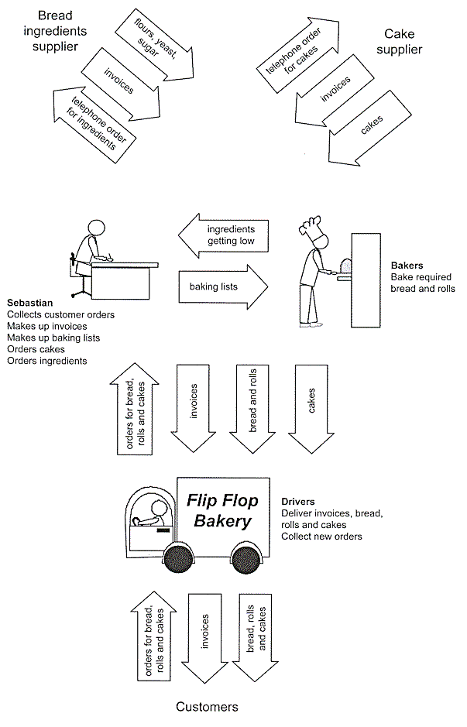

Figure 1

Kayla knows that to help Sebastian she must first fully understand the problems, and then analyse the current system.

To start her system analysis, Kayla has drawn the diagram (Figure 1 above). It shows the movement of goods, invoices and orders associated with Flip Flop Bakery's operation, and the role of the various people involved. She now has to create a logical design for the bakery's information system by drawing a context diagram and data flow diagrams, as well as constructing a data dictionary.

**Question 1**

Kayla has started the context diagram.

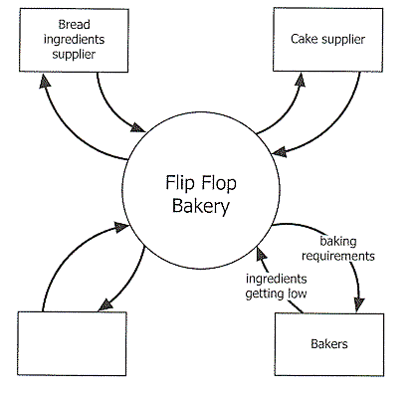

**a.** The label for the unnamed entity should be in the diagram above.

1 mark

**b.** Figure 1 in the case study shows three arrows going between the Cake supplier and the Bakery, but the context diagram only shows two. Explain this difference.

|  |
| --- |
|  |
|  |
|  |

1 mark

|  |
| --- |
| **c.**  Kayla has based her context diagram on Figure 1. Explain why she has drawn the Bakers as a separate entity. |
|  |
|  |
|  |

1 mark

**Question 2**  
Kayla has made three attempts to draw a data flow diagram for the processing of customer orders and determining the baking requirements. Consider the accuracy of the DFDs shown below.

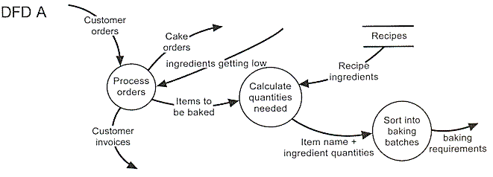

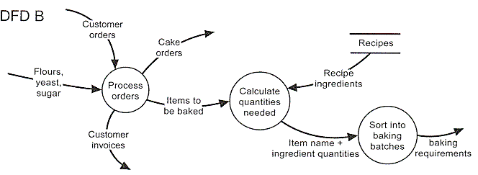

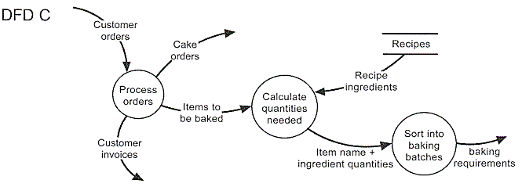

**a.**  Identify the **most correct** data flow diagram.

|  |
| --- |
|  |

1 mark

**b.** Explain the main error is in each of the other two data flow diagrams. (Make sure you clearly identify which DFD you are commenting about)

|  |
| --- |
|  |
|  |
|  |
|  |
|  |
|  |

2 marks

Kayla has also created a data dictionary, part of which is shown below.

|  |  |
| --- | --- |
| **Flip Flop data dictionary** | |
| **Name** | **Description** |
| Items to be baked | List of bread and bread rolls (items) to be baked for next day's requirements Composed of: Item name + quantity required |
| Recipe ingredients | Ingredients and quantities needed to bake a particular item Composed of: Item name + number made + ingredients list |
| Calculate quantities needed | Use recipe ingredients and items baked to work out how much of every ingredient is needed |
| Item name | Name of item to be baked; for example, multigrain loaf, bread roll |

**c.** Identify one inappropriate entry in the data dictionary and explain why it is inappropriate.

|  |
| --- |
|  |
|  |
|  |
|  |
|  |
|  |

2 marks

Kayla has completed her analysis of the system. She has decided to start the design of the new system with the design of the software. From her analysis she knows that the system needs to work out how many days of stock are available to the bakery for each ingredient. Where enough stock is not available, the quantity required must be determined for ordering

She designs an algorithm that

* takes in the number of days of stock order that needs to be catered for (Num_Days)
* takes in the total number of different ingredients that the bakery uses (Num_Ingredients)
* reads a file to get the total number of days of each ingredients Sebastian currently has in stock
* for each item of stock, checks amount of stock available (Stock_Amount)
* if insufficient stock for an ingredient calculate the amount required and store this (Qty())

PROCEDURE Calc_Order(Num_Days, Num_Ingredients)

BEGIN

Open File

Ingredient_ID <-- 1

REPEAT

Qty(Ingredient_ID) <-- 0

Ingredient_ID <-- Ingredient_ID + 1

Until Ingredient_ID > Num_Ingredients

REPEAT

READ Stock_Amount

Ingredient_ID <-- 1

REPEAT

Ingredient_ID <-- Ingredient_ID + 1

IF Stock_Amount < Num_Days

Qty(Ingredient_ID) = Num_Days - Stock_Amount

END IF

UNTIL Ingredient_ID = Num_Ingredients

UNTIL END OF FILE

Close File

END

**Question 3**  
**a.**  What is the purpose of the **first** REPEAT - UNTIL loop?

|  |
| --- |
|  |
|  |
|  |

1 mark

**b.** Describe the error in this algorithm.

|  |
| --- |
|  |
|  |
|  |

1 mark

**c.**  Suggest **one** way the algorithm could be altered to fix this error

|  |
| --- |
|  |
|  |
|  |

1 mark

**Question 4**  
Complete the following data table by inserting the correct data type from the options **integer, floating point, string, boolean, one dimensional array**.

|  |  |  |
| --- | --- | --- |
| **Variable** | **Use** | **Type** |
| Ingredient_ID | Loop Control on Ingredient ID |  |
| Num_Ingredients | Total Number of Ingredients |  |
| Qty( ) | Quantity in days of an Ingredient |  |

3 marks

**Question 5**  
Kayla and her uncle Michael, an experienced programmer, were discussing the best file structure to use to store the orders for each day. Sebastian has 300 regular customers who have different orders for each day of the week. As well he can have 50 casual orders on any day. Twenty-five per cent of his regular customers alter their daily order from week to week. Kayla suggests using a simple **Serial** Access file while Michael argues that due to the number of changes each day, a **Random** Access file would be best.

For the bakery's application, explain the advantage of the Random file structure for the organisation of this data.

|  |
| --- |
|  |
|  |
|  |
|  |
|  |
|  |

2 marks

**Question 6**  
Kayla now plans to set up the new system.  
She explains that buying the bakery computer and PDAs and setting them up will take about 3 days; writing, testing and debugging the programs for the bakery computer will take 20 days; writing, testing and debugging the programs for the PDAs will take 15 days; and testing the whole system and making sure it works could take 5 days.

**a.**  Complete the Gantt chart below to show how the four tasks could be completed inside 30 days.

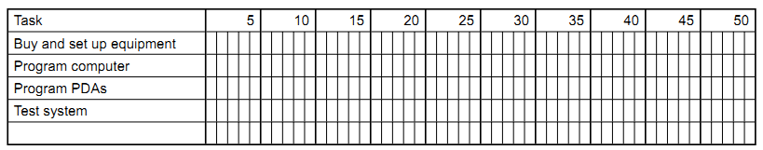4 marks

**b.** The task 'test system' is dependent on both programming tasks being completed first. Show this on your Gantt chart above.

1 mark

**Question 7**  
Michael has agreed to help write the programs for the new system. He has advised Kayla that he wants the programs to have good internal documentation: they should contain comment lines and all variables and procedures should have meaningful names. Kayla feels this is a waste of time as she can program much faster with short variable names and no comments.

Explain why Kayla should follow Michael's advice.

|  |
| --- |
|  |
|  |
|  |
|  |
|  |
|  |

2 marks

**Section C: Total 23 Marks**