Your name:

Unit 4  Outcome 1  Use spreadsheet software to solve an ongoing information problem, taking into account the information needs of an organisation, and evaluate the effectiveness of their problem-solving strategies. | 35 | A solution and information product in response to a design brief. Students annotate the solution and information product to indicate how the information needs of an organisation are met.
 | 15 | On-screen user documentation
 | 10 | A visual representation that retraces the decisions made and actions taken when problem solving, and evaluates the effectiveness of these strategies.

Note:
For this outcome, you will have 9 x 75 minute lessons to complete all three parts of the solution. You will not be allowed to take the task out of the room, or work on it at any other time apart from in class time.

The suggested break-up of time is as follows:

Task 1 – Spreadsheet solution | 30 marks | 4 –5 lessons
Task 2 – On-screen user documentation | 15 marks | 2 – 3 lessons
Task 3 – Visual representation (annotated flowchart) | 10 marks | You will need to do some work on this at the beginning, do more each lesson, and allow one lesson at the end to finish it off.

Final due date: _________________________________________
Outcome 1 - Task 1 (30 marks) A spreadsheet

Scenario – Wholesale Beauty Products
Wholesale Beauty Products (WBP) has operated for six years. The Managing Director of WBP is Jennifer Polidano. She manufactures a small but exclusive range of beauty products. Jennifer makes all of the products herself from certified organic ingredients, and boasts that the products are so natural, you could eat them without any harm. She is a true believer in women using natural beauty products, but also that they shouldn’t have to pay a lot of money for them. Jennifer employs four sales representatives, Maria, Eva, Mandy and Phuong, who each look after wholesale sales to various cosmetic and pharmacy outlets throughout Melbourne and regional Victoria.

Each representative looks after a certain geographical section of Victoria (this is called their ‘Territory’):

Representative Name | Territory | Geographical area covered
Maria Venuto | Northern | Northern suburbs and northern Victoria
Eva Stankovski | Southern | Southern suburbs and Mornington Peninsula
Mandy Smith | Western | Western suburbs and south-west Victoria
Phuong Nguyen | Eastern | Eastern suburbs and south-east Victoria

The products sold by WBP are listed below. All of the products come in a box of 10.

Product | Wholesale Price for box of 10
WBP Organic shampoo | $20.00
WBP Organic conditioner | $23.00
WBP Cleanser | $25.50
WBP Toner | $17.90

Because Jennifer manufactures all of the products herself, she needs to have accurate information about which ones are selling the fastest so that she will know how much of each product she needs to produce each month.

Jennifer also needs to know how much her sales representatives are making in sales each month, so that she can pay them a monthly bonus if applicable. Any salesperson who sells more than $6,000 worth of products each month gets a $500 bonus.

Jennifer is terrific at making good quality, natural beauty products, but she knows very little about computers, and she isn’t very well-organised. Currently Jennifer does the following to work out how to calculate each salesperson’s sales per month:

Firstly, at the end of each week, each salesperson fills in a form like this and hands it to Jennifer.
Jennifer then has to multiply the number of boxes sold by the price, and write it in the Total column, then add up the Total for the week for each salesperson.
Weekly sales
Sales Representative’s name: Phuong Week ending: 10/8/2007

Product | Number of boxes sold | Price | Total
WBP Organic shampoo | 10 | $20.00 | $200.00
WBP Organic conditioner | 20 | $23.00 | $460.00
WBP Cleanser | 5 | $25.50 | $127.50
WBP Toner | 10 | $17.90 | $179.00
Total for week |  |  | $966.50

She then transfers these amounts onto a monthly list for each representative, which looks something like this:

Total of sales for month
Sales Representative’s name: Phuong Sales for month: August

Total for week 1 | Shampoo | 10 | Conditioner | 20 | Cleanser | 5 | Toner | 10 | $966.50
Total for week 2 | Shampoo |  | Conditioner |  | Cleanser |  | Toner
Total for week 3 | Shampoo |  | Conditioner |  | Cleanser |  | Toner
Total for week 4 | Shampoo |  | Conditioner |  | Cleanser |  | Toner
Total sales for month | Shampoo |  | Conditioner |  | Cleanser |  | Toner

She has to do one of these for each of the four representatives. She sometimes gets distracted, or makes mistakes, and sometimes she writes the wrong amounts down for the wrong product, or the wrong salesperson.

At the end of the month, she adds up all the sales for each representative, so she can work out who will get a $500 monthly bonus.

She also adds up all the number of each product sold so that she knows how much to make for the next month.

Jennifer would like to have a much more efficient, foolproof way of working out all of these figures. She would like to be able to see in graphical form how each representative has performed with their sales at the end of the month, and would also like to see in graphical form which of her products are the best sellers.

The table below shows some data for the past month:
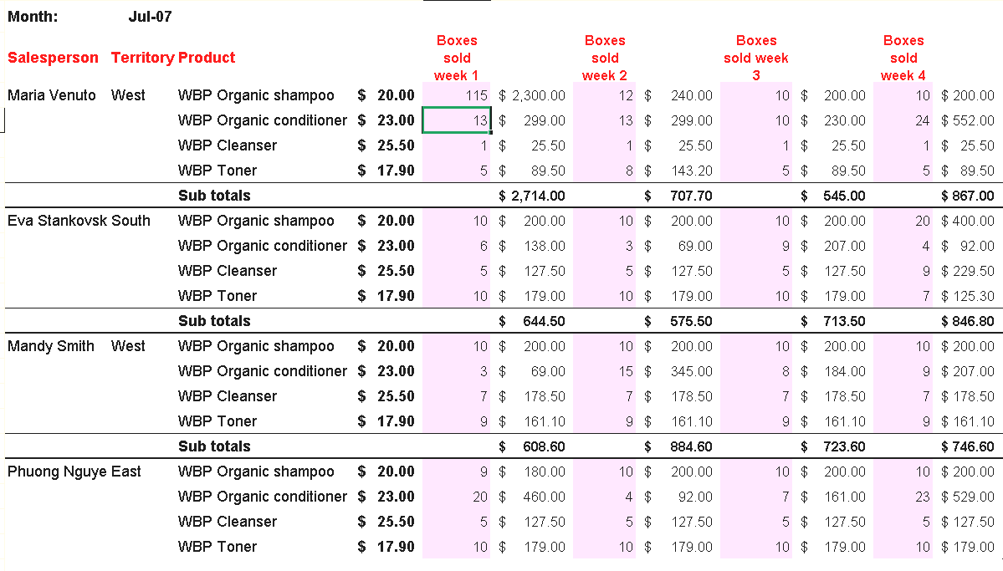

Jennifer has asked you to create a program that will enable her to do this quickly and easily. She is scared that she will ‘wreck’ the program because she doesn’t really know much about computers. You will have to make sure that there is appropriate validation, and that Jennifer will not be able to enter any data in the wrong places.

She hopes that she will not only have up-to-date information available on the screen, but that she will also be able to print out a report showing monthly totals of the sales representative’s totals, and a report that shows the number of boxes of each type of product sold per month.

She will also need some instructions about how to open the solution, enter the data, and how to view and print reports of totals and graphs.
Task 1 – Part 1 - Analysis
a) Organisational mission statement
Provide a one-sentence mission statement that would be suitable for Wholesale Beauty Products.

___________________________________________________________________________________

___________________________________________________________________________________

___________________________________________________________________________________
(1 mark)

b) Information System Goal
Provide a one-sentence statement that explains the goal of Wholesale Beauty Products’s information system

___________________________________________________________________________________

___________________________________________________________________________________

___________________________________________________________________________________
(1 mark)

c) Problem statement
Provide a one-sentence problem statement that begins with the “Problem is to…”

___________________________________________________________________________________

___________________________________________________________________________________

___________________________________________________________________________________
(1 mark)

d) Constraints
List and explain any constraints on the solution and information product that have been identified.

___________________________________________________________________________________

___________________________________________________________________________________

___________________________________________________________________________________
(1 mark)

e) What type of output (printed and on-screen) does Wholesale Beauty Products need?

___________________________________________________________________________________

___________________________________________________________________________________

___________________________________________________________________________________

(1 mark)

Task 1 Part 2 - Design

Provide an IPO chart for the spreadsheet solution

Input | Processing | Output

(1 mark)

Use this page to draw a structure chart for the spreadsheet
(1 mark)

Use these two pages to draw layout diagrams of two of the worksheets of your workbook (not the main menu/welcome page)
(2 marks)
Layout diagram 1
Layout diagram 2
Use this page to write up a formula list (in English, not in Excel code) to explain what formulas you will need for the solution. This includes Vlookups, If statements, etc

Output | Formula
(1 mark)

Task 1 Part 3 – Development of solution
The development of the spreadsheet solution is worth 20 marks. You will be marked on the following:

3.1 Development of solution:  Highly developed skills in the use of spreadsheet software, including Vlookup, formulas, IF statements, cell protection, graphs, macros | - Lookup tables  - Formulas  - If statements  - Cell protection  - Graphs  - Buttons/macros | 5 marks
3.2 Development of solution:  Relevant formats and conventions are applied to produce a very efficient and effective solution and information product. | - Report conventions  - Chart conventions  - On-screen data entry conventions | 5 marks
3.3 Development of solution:  All data validation techniques are appropriate and work correctly | - Only valid data can be entered (using drop-down boxes, notes/comments electronic validation etc) | 5 marks
3.4 Development of solution:  Testing – Testing table tests all parts of the solution | - Testing table (see next page) | 5 marks

Task 1 Part 3.4 Testing -
All elements of the spreadsheet must be tested, using the table below.
Element tested | Method of testing | Expected result | Actual result
(5 of 20 marks)
Task 1 Part 4 – Evaluation & Annotation
You must develop evaluation criteria that enable you to evaluate the extent to which your spreadsheet solution meets the needs of the organisation.

Your criteria must relate specifically to whether or not the solution meets the specified needs of the user after it is implemented. | How well does your website satisfy this criterion? |  |  | Explain why you have answered High, Medium or Low
Evaluation criteria | High | Medium | Low | Explain
1.

2.

3.

4.

(2 marks)

As part of the evaluation, you must then print out your spreadsheet solution, and annotate to explain how it relates to these evaluation criteria, and how you have met the information needs of the organisation.

Annotation (3 marks)

Outcome 1 - Task 2 (15 marks) On-screen user documentation

Answer the following questions:

What characteristics of the users at Wholesale Beauty Products could influence the design of the user documentation?

___________________________________________________________________________________

___________________________________________________________________________________

___________________________________________________________________________________
(1 mark)

- Considering the information needs of users at Wholesale Beauty Products, suggest three alternative solutions that could meet these needs (apart from the solution you have chosen).

___________________________________________________________________________________

___________________________________________________________________________________

___________________________________________________________________________________
(1 mark)

The selection in this case is on-screen user documentation. Justify on-screen user documentation as the best solution.

___________________________________________________________________________________

___________________________________________________________________________________

___________________________________________________________________________________
(1 mark)

Suggest two criteria to evaluate effectiveness of user documentation (do not confuse this question with evaluation of the solution – this question is only about evaluation of the on-screen user documentation)

___________________________________________________________________________________

___________________________________________________________________________________

___________________________________________________________________________________
(1 mark)

Design of on-screen documentation:
- Layout diagram of two screens of user interface
- Site map showing all navigation
(4 marks)

Use this page, and the following two blank pages to complete the layout diagrams and site map

Development:
The remainder of the marks for this section are based on the development of the on-screen user documentation. Marks will be awarded for the following:

- Appropriate formats and conventions used (fonts, colours)
- Navigation is appropriate and consistent
- Information is correct and complete
- Documentation is easy to follow
- Documentation is attractive
- Evidence of appropriate testing
- All links work
(7 marks)
Outcome 1 - Task 3 (10 marks) Annotated flow chart (Visual representation of the problem-solving process)
For this task, you must use a separate Excel document to create a flowchart using the correct symbols for processes, input, output, and decision making.

These flow chart symbols are found on the drawing toolbar under AutoShapes – Flowchart. When you use them in Excel, you can type straight into the shapes (in Word this isn’t possible)

The flow chart should show the processes you went through to:

analyse the information problem,

design, develop and test the solution, and

design, develop and test the user documentation

You must then annotate the flow chart with graphics such as
these callouts (also found in the drawing toolbar under AutoShapes) to show how you thought through the process.
Marking scheme for Outcome 1, Task 1 (total 35 marks)

Task 1 – An Excel Spreadsheet solution.

 | Very High  5 | High  4 | Medium  3 | Low  2 | Very Low  1 | Not shown  0
1. Analysis:  Comprehensive analysis of the information problem directly linking the nature and causes of the information problem with the goals of the information system and input and output requirements. All constraints on the solution and information product are identified. | - Problem statement  - Organisational goal and information system goal  - Input & Output  - Constraints
2. Design:  Appropriate design tools are used to thoroughly explain the structure, functions and format of the solution, including the user interface, and the structure and format of the information product. Soundly based and complete set of evaluation criteria and a comprehensive test plan, appropriate to the attributes being tested, are proposed. | - Structure chart  - Layout diagrams  - IPO chart  - Formula list
3.1 Development of solution:  Highly developed skills in the use of spreadsheet software, including Vlookup, formulas, IF statements, cell protection, graphs, macros | - Lookup tables  - Formulas  - If statements  - Cell protection  - Graphs  - Buttons/macros
3.2 Development of solution:  Relevant formats and conventions are applied to produce a very efficient and effective solution and information product. | - Report conventions  - Chart conventions  - On-screen data entry conventions
3.3 Development of solution:  All data validation techniques are appropriate and work correctly | - Only valid data can be entered (using drop-down boxes, notes/comments electronic validation etc)
3.4 Development of solution:  Testing – Testing table tests all parts of the solution | - Testing table
4. Evaluation:  Comprehensive annotations to the solution and information product, which are all directly linked to the evaluation criteria, thoroughly explain how the information needs of the organisation are met. | - Evaluation questions (p ..)  - Print-outs of solution annotated to link the evaluation criteria with the solution
Total Score for Task 1 | ________ / 35

Marking scheme for Outcome 1, Task 2 (total 15 marks)

Task 2 – On-screen documentation

 | Very High | High | Medium | Low | Not Shown
Answers to questions regarding:  the characteristics of users within the organization that could influence the design of the user documentation  - Information needs of users and three solutions that could meet these needs  Justify selected solution  Criteria to evaluate effectiveness of user documentation | 4 | 3 | 2 | 1 | 0
Design of on-screen documentation:  - Layout diagram of user interface  - Site map showing all navigation | 4 | 3 | 2 | 1 | 0
Development:  - Appropriate formats and conventions  - Documentation is easy to follow  - Documentation is attractive  - Evidence of appropriate testing  - All links work | 7 | 5-6 | 3-4 | 1-2 | 0
Total Score for Task 2 | _______  15

Marking scheme for Outcome 1, Task 3 (total 10 marks)

Task 3 – A visual representation that retraces the decisions made and actions taken when problem-solving, and evaluates the effectiveness of these strategies.

 | Very High  5 | High  4 | Medium  3 | Low  2 | Very Low  1 | Not shown  0
Highly developed skills in the use of software tools to create an effective visual representation of all the thinking strategies used to:  analyse the information problem,  design, develop and test the solution, and  design, develop and test the user documentation | Flowchart is correct in all respects, using correct symbols etc  All three dot points:  analyse the information problem,  design, develop and test the solution, and  design, develop and test the user documentation  are covered in depth | Flowchart is correct in most respects, using mostly correct symbols etc  All three dot points:  analyse the information problem,  design, develop and test the solution, and  design, develop and test the user documentation  are covered | Flowchart is correct in most respects, using mostly correct symbols etc but may have some errors or omissions  All three dot points:  analyse the information problem,  design, develop and test the solution, and  design, develop and test the user documentation  are covered | Flowchart is correct in some respects, using some correct symbols etc but may have some errors or omissions  Only one or two of the three dot points:  analyse the information problem,  design, develop and test the solution, and  design, develop and test the user documentation  are covered | An attempt has been made to create a flowchart but it uses incorrect symbols or does not provide a visual representation of thinking strategies  An attempt has been made to cover the dot points, but is incorrect or incoherent | Not submitted
Comprehensive evaluation of the effectiveness of these strategies is based on sound, appropriate criteria and is demonstrated in comprehensive annotations or modifications to the visual representation | Notes and annotations to flowchart are comprehensive, logical and relevant  Evaluation of the strategies taken and decisions made is insightful and shows a development of thought processes throughout the problem solving process | Notes and annotations to flowchart are comprehensive  Evaluation of the strategies taken and decisions shows some insight, and shows a development of thought processes throughout the problem solving process | Notes and annotations to flowchart are adequate  Evaluation of the strategies taken and decisions shows some insight. | Notes and annotations to flowchart are adequate but may have errors or omissions  Evaluation of the strategies taken and decisions is basic | An attempt has been made to annotate the flowchart in some way  Evaluation of the strategies taken and decisions is very basic and simple | Not submitted

Total Score for Task 3
___
10

