
ITA – Outcome 2, Task 2 – Closed book test
Task 2 will contribute 20 marks of the 50 marks for Outcome 2.
A test that focuses on the evaluation of the prototype and the recommended network requirements for the organisation and one team member.
Part 1 – Multiple choice questions – please transfer your answer to the attached multiple choice answer sheet.

- A hardware and software combination that filters information coming through an internet connection to a LAN is called a:
  - Packet switch
  - Firewall
  - Protocol
  - IP address

- Encryption is:
  - the process of translating data into a secret code that can be only be read by authorised users
  - Updating antivirus software automatically via the network
  - Ensuring that firewall settings are up-to-date
  - Ensuring that all users change their passwords on a regular basis

- The logical design of a network includes:
  - network protocols
  - network speed
  - network security issues
  - all of the above

- TCP/IP is:
  - a wireless communications standard
  - a type of NIC
  - software that enables the uploading and downloading of files with other computers on the internet
  - the most common method of packaging data for network transmission

- An Ethernet frame (or ‘packet’) would typically contain:
  - a destination address, data and parity check
  - a destination address, source address, data and token
  - a destination address, source address, data and parity check
  - a destination address, protocol, data and parity check

- What is the name of the network architecture that enables and allows all devices to share files and resources:
  - bus network
  - client/server network
  - tree network
  - peer to peer network

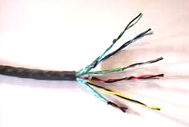
- The type of cable shown here is:
  - fibre-optic cable
  - co-axial cable
  - twisted pair cable
  - wireless cable

- A wireless access point is:
  - the process of moving around a wireless network
  - a device that determines the best path for packets to follow
  - a central communications device that allows computers and devices to transfer data wirelessly to a wired network
  - a central communications software that controls wireless network traffic

- A network operating system is:
  - software used to control network traffic
  - rules used to build data packets
  - software that allows a user to view pages on the internet
  - software that allows the transmission of audio and video signals over the internet

- A mock-up diagram is:
  - A special type of latin text also known as ‘Lorem Ipsum”
  - A sample of a webpage that a designer is going to use drawn up in a computer drawing program
  - A sample of a webpage that a designer is going to use drawn up by hand
  - A diagram indicating screen dimensions, list of required image filenames and list of required link filenames

- Which of the following elements of design for web pages is most important if your audience is likely to have only dial-up internet access:
  - The ability to locate information easily
  - Simple but attractive design
  - Consistent colours, fonts and navigation throughout the site
  - Any images are of a small file size

- After what period of time from initial implementation should a website solution be evaluated for effectiveness?
  - One week
  - One month
  - Six months
  - One year

- What is groupware?
  - Software that connects LANs to WANs, such as the Internet
  - Software the controls traffic on a network
  - Software that provides a medium for groups of people to work together and share information
  - Software that enables a wireless-enabled computer to communicate with an AP

(13 marks)
Part 2 – Short answer questions
- As part of Task 1, you were required to list six different evaluation criteria that you could use to measure the success of your solution. They should relate specifically to whether or not the solution meets the specified needs of the user (Greenearth).

Select two of those criteria, and for each criterion, explain in detail how your solution will enable Greenearth to satisfy those criteria.

Criteria (restate the criteria) ___________________________________________________

__________________________________________________________________________

__________________________________________________________________________

__________________________________________________________________________

__________________________________________________________________________

__________________________________________________________________________

__________________________________________________________________________

__________________________________________________________________________
(3 marks)

Criteria (restate the criteria) ___________________________________________________

__________________________________________________________________________

__________________________________________________________________________

__________________________________________________________________________

__________________________________________________________________________

__________________________________________________________________________

__________________________________________________________________________

__________________________________________________________________________
(3 marks)

- Greenearth currently runs a LAN at their head office in Melbourne.

They have three servers:
  - File server
  - Web server
  - Print server

Explain the role of these servers:
- File server

_____________________________________________________________________________

_____________________________________________________________________________
(1 mark)
- Web server

_____________________________________________________________________________

_____________________________________________________________________________
(1 mark)
- Print server

_____________________________________________________________________________

_____________________________________________________________________________
(1 mark)

- Greenearth currently has 3 hubs to take in and broadcast out all signals to workstations and devices on their LAN. Someone has suggested that they should replace the hubs with switches. Differentiate between hubs and switches, and explain the advantages and/or disadvantages to Greenearth in making this change.

_____________________________________________________________________________

_____________________________________________________________________________

_____________________________________________________________________________

_____________________________________________________________________________
(3 marks)

- All volunteers and employees at Greenearth have their own username and password to access the network. They are always advised to make sure their passwords are ‘suitable’ passwords that will ensure that Greenearth maintain a high level of security. Provide some guidelines as to what a ‘suitable’ password should be:

_____________________________________________________________________________

_____________________________________________________________________________

_____________________________________________________________________________
(2 marks)

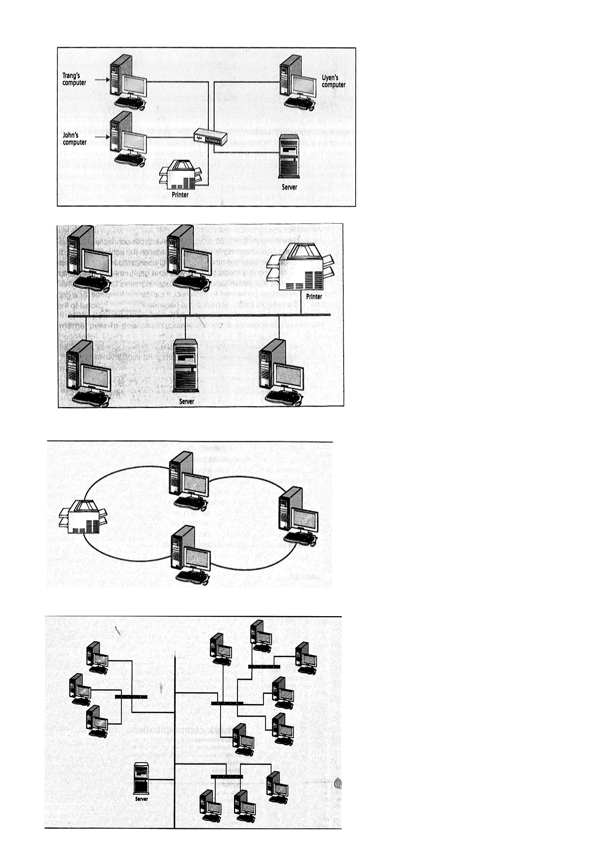
- The topology of Greenearth’s LAN is a star arrangement. Label the topologies of the network diagrams shown below.
a) __________________________
d) __________________________
c) __________________________
b) __________________________
Graphics from IT Applications – Colin Potts et al, Thomson Nelson 2007
(4 marks)

- What advantages does a star network have over other topologies?

_____________________________________________________________________________

_____________________________________________________________________________

____________________________________________________________________________

_____________________________________________________________________________
(2 marks)

- One of Greenearth’s volunteers has a computer at home, and would like to do some of the Greenearth work ‘remotely’ at home so that he doesn’t have to travel to the office every day. His work includes putting updates on to their website, and sending email. Although he has a fairly modern computer, it isn’t connected to the Internet. Apart from a modem, list and explain two items of hardware, software or other technology that he will need to be able to communicate with the head office by computer.

Item 1: _______________________________________________________________________

_____________________________________________________________________________
(2 marks)

Item 2: _______________________________________________________________________

_____________________________________________________________________________
(2 marks)

- There are three different categories of types of modems. List and explain two types, and explain the role of a modem.

Modem type 1: ________________________________________________________________

_____________________________________________________________________________

_____________________________________________________________________________
(2 marks)
Modem type 2: ________________________________________________________________

_____________________________________________________________________________

_____________________________________________________________________________
(2 marks)
The role of a modem: (ie. What does it do?) _________________________________________

_____________________________________________________________________________

_____________________________________________________________________________
(2 marks)

- The staff at Green Earth are considering expanding their LAN by purchasing a laptop with a wireless card and the other hardware and software required for a wireless network. Explain one advantage and one disadvantage of wireless networks.

Advantage: ___________________________________________________________________

_____________________________________________________________________________

_____________________________________________________________________________

Disadvantage: ________________________________________________________________

_____________________________________________________________________________

_____________________________________________________________________________
(1 + 1 = 2)

- If Green Earth does purchase a laptop with a wireless enabled laptop, they will be able to take advantage of hot spots. What are hot spots and where might you find them?

_____________________________________________________________________________

_____________________________________________________________________________
(1 mark)
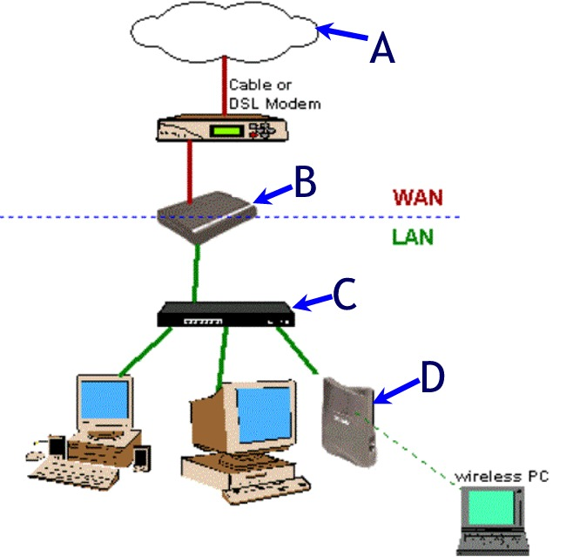
- Label the network components shown as A, B, C and D on the diagram below
- _______________________

B.________________________

- _______________________

D._________________________

(4 marks)

END OF TEST

