Marvelous Mechanisms ‘Automata’

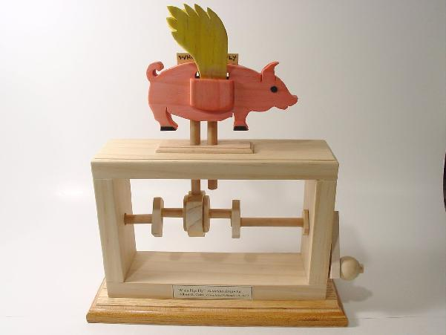

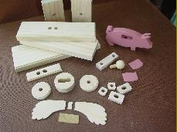
Automata
During this project you will be learning about different mechanisms
And their effect on movement. You will be required to produce a
model that demonstrates at least one type of motion. This will be
done through the production of an ‘Automata’. An automata is a type
of toy that uses cams and levers to make parts move – to automate
it. A base holds the mechanism and the model is added to the top.
Designing your own Automata takes a little time and effort.
Coming up with creative solutions is not easy.

Inspiration
Mechanical toys and automata often appear to have a life of there
Own the simple mechanical parts seem to produce an almost magical
response to the the figures that they move. Automata come in a
vast range of sizes and varying degrees of complexity. Some may
keep your interest for several minutes whilst others you may just
pass by. What makes an automata “good” is very subjective. We all
like different things and we don’t all find the same thing funny. As
the great saying goes “ You can’t please all of the people all of the
time.” So where do you start. The check list below gives some simple suggestions against which to test your ideas.
Is it visually exciting? Is it funny? Will it intrigue the viewer? Will it hold the viewers attention for at least a minute? Is it too complex? Is the humour to obscure?
This is just a general check list and is by no means a full proof system for producing the perfect automata, but it does help to weed out good ideas from the bad. As a general rule at the start, it may be a good idea to base your ideas on something that you are interested in such as a sport, a hobby, etc. Animals can provide a wonderful subject on which to base a theme for an automata. As with any creative process, coming up with the idea is often the hardest part of the whole process. You may on the other hand be lucky and be brimming with ideas. But it’s probable fair to say that most people have to work hard at the inspirational or ideas stage.
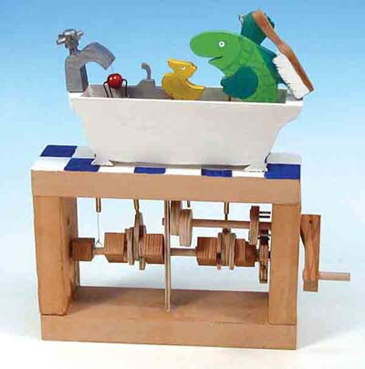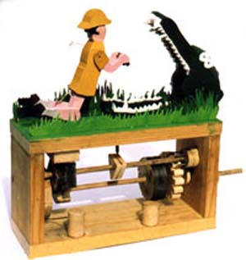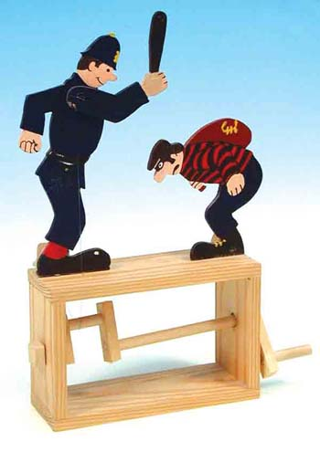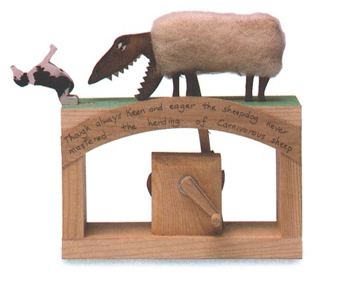

Marvelous Mechanisms ‘Automata’ Research

To help you come up with an idea you need to research the topic. The purpose of research is to get as much information as you can about your subject. This helps you to work out how something moves, the colours, the scale etc. Refer to things such as photos, pictures, photocopies etc. look at what other people have created.
The example on the right has a hunter on the top that rotates when the handle is turned, and the hippo appears from behind the tree when the hunter is facing away from him. What do you think happens with the example on the left?

Designing the top section
You are to design an automata top that demonstrates one type of motion. It needs to fit onto the top of a standard frame. Careful thought needs to be given to 1. The size of the animation – it must fit onto the base section. 2. The parts that will move and how they need to be joined. 3. How to transfer the motion from the shaft in the base to the animation at the top.

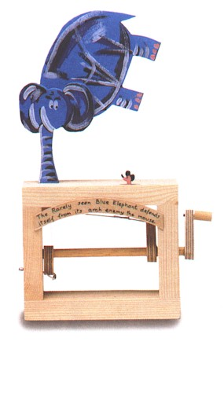
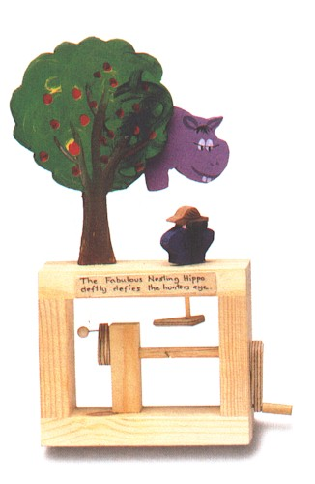

The following sites will lead you on to a number of topics designed to help you understand more about mechanisms, basic engineering principles as well as designing and making your own automata.

http://www.automata.co.uk/mainpage.html
http://www.cabaret.co.uk/
http://www.flying-pig.co.uk/
http://www.fourteenballstoy.co.uk/
http://www.keithnewsteadautomata.com/
http://www.mechanicalmonkey.co.uk

You can use clip art to create your figures too. Print out any images you find that might be useful.

WHAT TO DO

1. In your work books you will produce at least 3 design options for your Automata. Each design should be drawn large and contain enough detail to allow others to understand the design. Add annotations to explain your designs. Use motion symbols to indicate what will move and in what direction. Under each design write what you do and don’t like about the design. Indicate which design you would like to make. Make a ruled drawing of your chosen design. Include all measurements. When you are happy with your design you will need to complete a cutting list. (complete the example cutting list first)
2. Work out how you will transfer the movement from the shaft to the model. Make diagrams/ notes in your workbook about how to make it work. Work out where any holes will need to be drilled in the frame and where cams will be positioned in the shaft.

Tip 1 – Look at some of the ideas on the wall or view some of the web sites on automata. You will need to have a page in your workbook that shows existing ideas.
Tip 2 – Use clip art, children’s books and colouring in books to find shapes of animals, characters etc.

Production
Students follow their work plan and use suitable equipment and techniques to construct their automata. They solve problems as they arise and document any modifications. Students will be given further demonstrations of techniques as they work. Final assessment will be based upon the originality of the design, the functionality of the design and the final ‘finish’ of the product.

Tools/equipment to be used

Scroll Saw, Claw Hammer, Pincers, Nail Punch, Nails, Steel Ruler, Workbook, Sharp H pencil, PVA glue, Sand paper, Electric disc sander, paint, drill, drill bits, timber.
