Year 8: Design Beyond the Box
Acoustic Phone Speaker
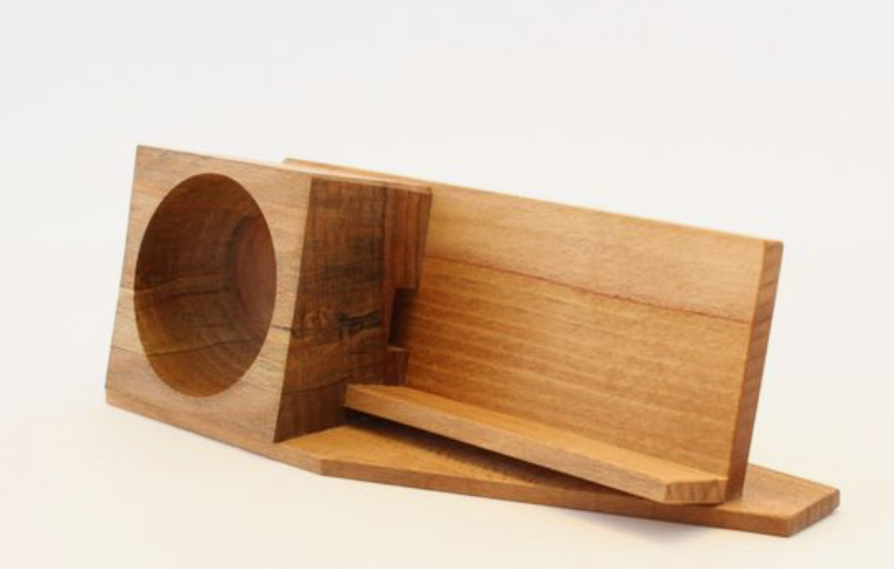
Design task

Design Brief
The sound that comes from your phone doesn’t travel far and is soft and tinny.
https://www.etsy.com/au/listing/198652834/?ref=market&epik=dj0yJnU9UVNZVy12b0JrZEh3RnRmalFWa3JkbThvZEZNYUttTlcmcD0wJm49NDhYaTlJZHhYUEdLTEtYUjlQOTZ2USZ0PUFBQUFBR0NGWjVB
You need to design and make an acoustic speaker that amplifies the phone’s sound (makes it louder) and that looks interesting.

Constraints – your design needs to fulfil the following requirements:
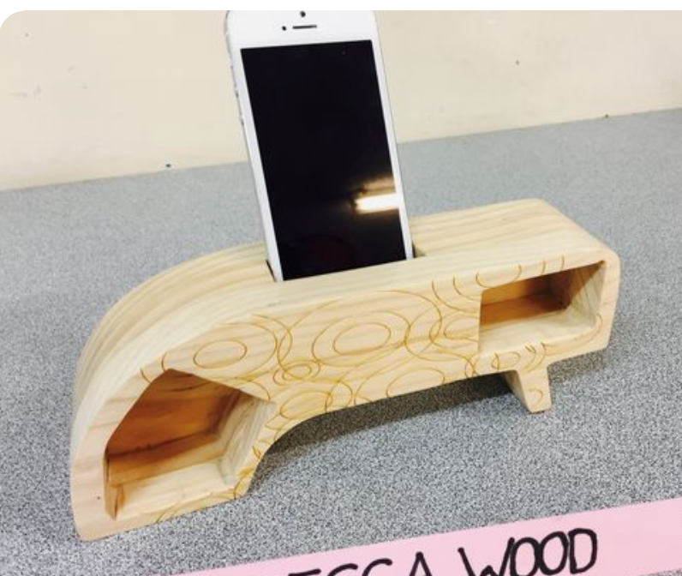
- Must fit a specific phone (either yours or for someone else you know)
- Must increase the sound volume of the phone
- Your speaker can be no larger than 300mm x 200mm x 140mm
- Will involve some joining of materials (may include butt joints or layering)
https://i.pinimg.com/originals/6c/e4/5f/6ce45fc06837e93c41b99d56a20cddeb.jpg
- Must be varnished or oiled (for protection)

Design choices – areas where you need to make decisions:
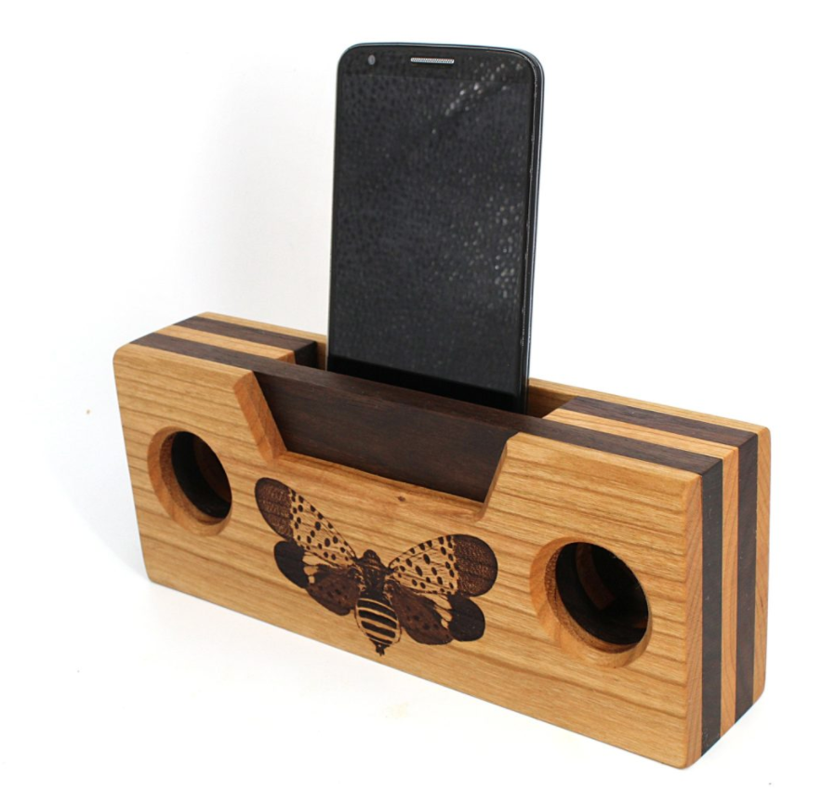
- The shape of your acoustic speaker (within the size limits) and the type of construction
- Any decorative design
- About how your phone will sit in the speaker
- About how the sound will escape
shop.coolmaterial.com
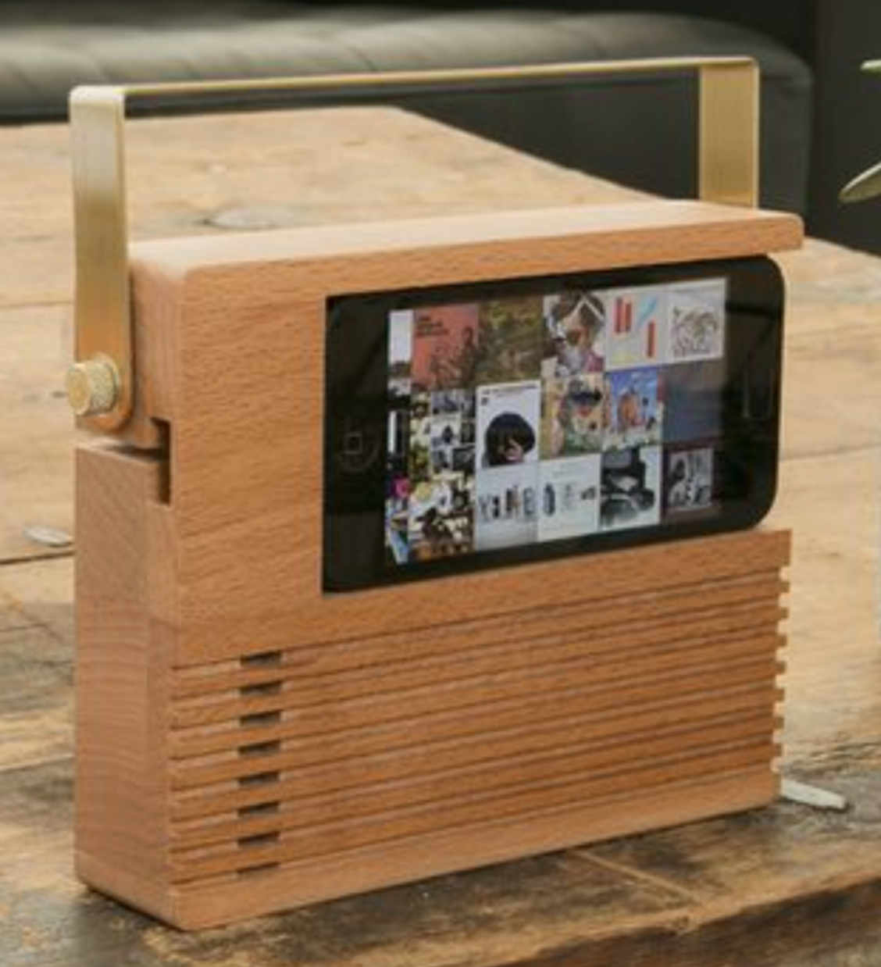

Your assessment criteria - things I will look for to check whether you’ve designed and made a great acoustic speaker:
- That you have properly thought about and discussed the design task
- That your design drawings are well done and have all the required information (measurements, joins, lid drawing, etc.)
- That the speaker design is interesting and creative, and has some decorative features
- That your cutting and construction have been completed accurately
- That you have worked safely in a planned and productive way

Acoustic speaker - your tasks

Step 1 – Design brief
In your visual diary, complete a decision map that brainstorms aspects of your speaker design choices. It should describe lots of ideas related to – phone size, where the speaker will be placed, the type of decoration you could use, colours or materials, joints and speaker construction. Highlight the aspects of your brainstorm that you choose to incorporate into your design work. This is a plan – you use this mind-map information to write your design brief. Under the map there is space for summarising all of the information related to your choices. (You should fill most of the lines – if not, you’ve probably left some aspect out)

Step 2 – Evaluation criteria
Read and fill in the task to list 4-6 evaluation criteria for your finished acoustic speaker. Make sure that your criteria are good for setting the standard you expect, and are not asking for just a descriptive answer. You will be asked to write criteria that cover the areas of function, construction and appearance.

Step 3 – making a cardboard trial
Use a piece of tube and a disposable cup to create a trial speaker and test its results.

Step 4 – Research
Researching your phone – measure your phone accurately (or find the dimensions from the internet) and identify the
Researching different designs - Find 6 images of different types of acoustic speakers (sometimes they are called passive speakers). In a PowerPoint:
- display the images,
- include the URL of each image
- describe and analyse each design/product

Step 5 – Design sketches
Develop 4 clear sketches of ideas for your speaker (on 1-2 pages) – make sure you:
- include colour (don’t forget to include timber colour and grain).
- indicate where the phone will be positioned and explain (in drawings and words) how the speaker works – i.e. how the sound travels from your phone to the sound cavity.
- Think about shaping and decorative features (e.g. stripes, holes, cut-outs, acrylic pieces, etc.).
- Indicate which design is the best, and explain why you want to make it (1-2 sentences)

Step 6 – Orthogonal drawing of your acoustic speaker
Draw you chosen speaker design using the orthogonal drawing method (as demonstrated) – you must show the side view and top view. Use a ruler and be accurate. You need to show thickness of the timber, and the speaker’s measurements and joins on your drawing.
You may need to also draw the shapes of your individual layer (to scale/full size)

Step 7 – Materials cutting list
Fill in the table to list the measurements of your speaker parts

Step 8 – Making your speaker
You need to construct your speaker. This will involve

- Marking out your timber
- Cutting your pieces, checking and adjusting length
- Marking out your joins
- Cutting and chiselling joins
- Completing decorative designs (if needed)
- Sanding (not your joins)
- Dry check and adjusting if needed
- Gluing and nailing
- Final sand and varnish

Step 9 – Plan and Journal
Create a simple production plan to guide you while you are making your speaker – it should explain the main steps you need to complete during construction. Print this and stick it into your visual diary - highlight each stage as you complete the stage. On Stile, you will need to complete a journal for each of the major stages of production – to do this, you need to take photos of your work as you make your speaker, and answer some simple reflection questions.

Step 10 – Evaluation
Evaluate your work – make judgements about your speaker using the criteria you wrote earlier in the process.

