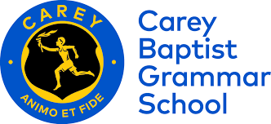

15th July 2020

To whom it may concern,

(Student name here) is currently a Year 10 student at Carey Baptist Grammar School.
He/she is enrolled in year 10 in a Design Engineering elective course. The Couse will take place from July 2020 to December 2020

If you require any further information, please contact me via the below contacts

Regards,

(Add signature here)

Ms Felicity McNamara
(03) 9816 1576
Felicity.mcnamara@carey.com.au

