Article for FULL STEaM AHEAD Program July 2018

FULL STEaM AHEAD - Girls Designing an Inclusive Society. A one-week STEM based work experience program for Year 10 Girls. 9 - 13 July 2018

FSA Team October 2017
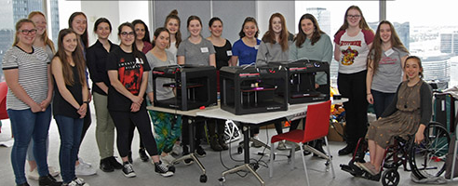

Akorn Educational Services are pleased to offer this amazing opportunity for Year 10 girls to participate in the 5-day 2018 FULL STEaM AHEAD - Girls Designing an Inclusive Society program.

In a recent World Report on Disability, it is estimated that 1 in 5 people globally has a disability, which in Australia is calculated to be 4.27 million people. The majority of these people experience social exclusion, discrimination and lack of access to fully participate in society due to the barriers such as built environment and negative attitudes.

Responding to this challenge, students will collaborate to generate ideas and develop assistive/enabling technologies that will overcome said barriers. During the program students will be supported by the Akorn Educational Services team to establish the appropriate analytical framework and user centered design to come up with sustainable and viable solutions.

Click HERE to apply.

For further details, visit akorn.com.au/fsa or contact Georgene Bridgeman:
E: georgene.b@AKORN.com.au or M: 0412 339 553.

Email Georgene to receive an A3 promotional poster for this program, or click on the image below to download your own version.

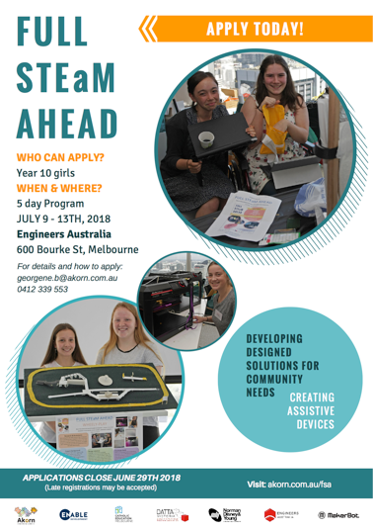
Kindly sponsored by Norman Disney & Young,
Catholic Education Melbourne, Engineers Australia, and supported by Enable, DATTA VIC and MakerBot

